**EBARANGAY: AN APPLICATION MANAGEMENT SYSTEM**

**WITH PUROK INTEGRATION AND**

**FLOW OF WORKLOAD**

A Capstone Project Presented to the Faculty of

College of Computer, Information and Communication Technology Department

Cebu Technological University - Main Campus

In Partial Fulfillment of the Requirements

for the degree Bachelor of Science in Information Technology

By:

Craige Jonard N. Baring

Sajid O. Cadavero

Rosvie R. Pepito

Narcisan Galamiton, Ph. D

Adviser

May 2021

**APPROVAL SHEET**

The Capstone Project entitled eBARANGAY: AN APPLICATION MANAGEMENT WITH PUROK INTEGRATION AND FLOW OF WORKLOAD prepared and submitted by Craige Jonard N. Baring, Rosvie R. Pepito, and Sajid O. Cadavero has been examined and is recommended for approval and acceptance.

Recommended:

**NARCISAN GALAMITON, Ph. D** Adviser

APPROVED by the Committee on PROPOSAL HEARING with a verdict of APPROVED WITH MAJOR REVISIONS on June 15, 2021.

**PET ANDREW P. NACUA, MIT**

Chairman

**GIBE S. TIROL, MIT** **BELL S. CAMPANILLA, Ph. D**

Panel Member Panel Member

**ACCEPTED** and **APPROVED** in partial fulfillment of the requirement for the degree of **Bachelor of Science in Information Technology.**

**GERRY RITZ R. DENSING, Ph. D**        Associate Dean, CCICT

**JOSE MARIA S. GARCIA II, Ph. D**     DEAN, CCICT

**ACKNOWLEDGMENT**

The Team RJS would like to extend our deepest appreciation to the people who helped and contributed to the success in this study.

First of all, we would like to thank the Almighty God for giving us courage and strength while working with this study. This study would not be done without his guidance.

We also extend our deepest gratitude to those who support this work especially our parents, supporting us emotionally and financially, trusting and believing us all throughout the way. We also thank our close friends, and classmates, who gave advice, and opinions for the improvements of this study.

To our adviser, **Ms. Narcisan Galamiton**, for giving us assistance and support with the research.

To our professor, **Mr. Bell Campanilla**, for guiding us with our research, and to give out necessary feedback for us to grow better.

To us, the researchers, **Rosvie R. Pepito**, **Sajid Cadavero**, and **Craige Jonard N. Baring** for working together as a team in creating this study.

**DEDICATION**

This study is dedicated to the people who believed in our skills and determination. To our loving parents for their undying support, guidance, and understanding along the way. Also, the people, workmates and friends who helped us in their own little ways in this study. To the faculty members who shared their knowledge and experiences to us. To our supportive adviser who has supported and guided us along the way. And especially to our Creator, the Almighty God for giving us strength, and faith to conduct this study.

**TABLE OF CONTENTS**

TITLE PAGEi

APPROVAL SHEETii

ACKNOWLEDGEMENTiii

DEDICATIONiv

TABLE OF CONTENTSv

LIST OF TABLESvii

LIST OF FIGURESviii

**CHAPTER I** 1

**INTRODUCTION** 1

Rationale of the Study1

Objectives of the Study3

Significance of the Study5

Flow of the Study6

Definition of Terms 7

**CHAPTER II** 8

**REVIEW OF RELATED LITERATURE AND STUDIES** 8

Related Literature8

Related Studies9

**CHAPTER III** 13

**RESEARCH METHODOLOGY** 13

Scope and Limitations13

Software Engineering Methodology 14

Planning Phase16

Business Model Canvas16

Program Workflow17

Gantt Chart23

Functional Decomposition Diagram 25

Analysis Phase 26

Use-Case Diagram 26

Storyboard 33

Database Design 58

Entity-Relationship Diagram 58

Data Dictionary 59

Network Design 65

Network Model 65

Network Topology 66

Development Phase 67

Technology Stack Diagram 67

Software Specification 68

Hardware Specification 68

Program Specification 69

List of Modules 69

REFERENCES 74

APPENDICES 75

Appendix A. Capstone 1 Oath of Confirmation 75

Appendix B. Research Working Title Form 78

Appendix C. Capstone 1 Consultation Logs Form 79

CURRICULUM VITAE 81

LIST OF TABLES

Table 1: Comparative Matrix 12

Table 2: Capstone 1 Gantt Chart: Projected . 23

Table 3: Capstone 1 Gantt Chart: Completed23

Table 4 Capstone 2 Gantt Chart: Projected24

Table 5: eBarangay Data Dictionary64

Table 6: Manage Account Module 69

Table 7: Request Document Module 70

Table 8: Ebulletin Module 70

Table 9: Manage Complaints Module 71

Table 10: Manage Residents Module71

Table 11: Manage Organizations Module 72

Table 12: Manage Notifications/Messages Module 72

Table 13: Manage Barangay Module 73

Table 14: Voting Module 73

**LIST OF FIGURES**

Figure 1: BeST Barangay System10

Figure 2: e-Barangay visual of their functionality11

Figure 3: Iterative Model - Design14

Figure 4: Business Model Canvas16

Figure 5: Program Workflow - Resident17

Figure 6: Program Workflow – Purok18

Figure 7: Program Workflow – Treasurer19

Figure 8: Program Workflow – Secretary20

Figure 9: Program Workflow – Captain21

Figure 10: Program Workflow – Admin22

Figure 11: Function Decomposition Diagram25

Figure 12: Use Case – Barangay Resident26

Figure 13: Use Case – Barangay Purok27

Figure 14: Use Case – Barangay Secretary28

Figure 15: Use Case – Barangay Treasurer29

Figure 16: Use Case – Barangay Captain30

Figure 17: Use Case – Admin31

Figure 18: Use Case – Resident Verification32

Figure 19: Storyboard – Webpage - Homepage33

Figure 20: Storyboard – Choose Account33

Figure 21: Storyboard – Register Page33

Figure 22: Storyboard – Login Page33

Figure 23: Storyboard – Resident Acc Request33

Figure 24: Storyboard – Confirmation Page33

Figure 25: Storyboard – Resident eBulletin34

Figure 26: Storyboard – Request Prompt34

Figure 27: Storyboard – Request Form34

Figure 28: Storyboard – Payment Request Form34

Figure 29: Storyboard – Receipt34

Figure 30: Storyboard – Document Request Form34

Figure 31: Storyboard – eReklamo prompt35

Figure 32: Storyboard – Concern35

Figure 33: Storyboard – Concern request sent35

Figure 34: Storyboard – Request35

Figure 35: Storyboard – Request sent35

Figure 36: Storyboard – Organization35

Figure 37: Storyboard – Join Org36

Figure 38: Storyboard – Upload Requirements36

Figure 39: Storyboard – Join Request sent36

Figure 40: Storyboard – Org member36

Figure 41: Storyboard – Org Content36

Figure 42: Storyboard – Notification36

Figure 43: Storyboard – Message Compose37

Figure 44: Storyboard – Message sent37

Figure 45: Storyboard – Document Requests (PUROK LEADER37

Figure 46: Storyboard – My Profile37

Figure 47: Storyboard – Post content37

Figure 48: Storyboard – Request content37

Figure 49: Storyboard – Resident’s message38

Figure 50: Storyboard – Resident Info38

Figure 51: Storyboard – Purok Leader Signature38

Figure 52: Storyboard – Request/Concerns info38

Figure 53: Storyboard – Notification38

Figure 54: Storyboard – Report38

Figure 55: Storyboard – Report Content39

Figure 56: Storyboard – Treasurer homepage39

Figure 57: Storyboard – Payment39

Figure 58: Storyboard – Payment Details39

Figure 59: Storyboard – Report39

Figure 60: Storyboard – Report Content39

Figure 61: Storyboard – Report40

Figure 62: Storyboard – Secretary homepage40

Figure 63: Storyboard – Secretary request sign40

Figure 64: Storyboard – Secretary request sign40

Figure 65: Storyboard – Secretary request sign40

Figure 66: Storyboard – Secretary eReklamo40

Figure 67: Storyboard – Secretary eReklamo content41

Figure 68: Storyboard – Secretary residents41

Figure 69: Storyboard – Secretary verify account list41

Figure 70: Storyboard – Account verification page41

Figure 71: Storyboard – Report content41

Figure 72: Storyboard – Brgy Captain homepage41

Figure 73: Storyboard – Signature requests42

Figure 74: Storyboard – Document requests42

Figure 75: Storyboard – Request content42

Figure 76: Storyboard – Concern/Request list42

Figure 77: Storyboard – Resident’s message42

Figure 78: Storyboard – Resident list42

Figure 79: Storyboard – Resident list43

Figure 80: Storyboard – Organization43

Figure 81: Storyboard – Reports43

Figure 82: Storyboard – Report content43

Figure 83: Storyboard – Notifications43

Figure 84: Storyboard – Android - Homepage44

Figure 85: Storyboard – User account44

Figure 86: Storyboard – Login44

Figure 87: Storyboard – Register44

Figure 88: Storyboard – Account created45

Figure 89: Storyboard – eBulletin45

Figure 90: Storyboard – Menu45

Figure 91: Storyboard – Request45

Figure 92: Storyboard – Request Docu46

Figure 93: Storyboard – Payment46

Figure 94: Storyboard – Receipt46

Figure 95: Storyboard – Request Document (NON -VOTER)46

Figure 96: Storyboard – eReklamo47

Figure 97: Storyboard – eReklamo Concern47

Figure 98: Storyboard – eReklamo Request47

Figure 99: Storyboard – eReklamo sent47

Figure 100: Storyboard – Organization48

Figure 101: Storyboard – Join Org48

Figure 102: Storyboard – Request Join sent48

Figure 103: Storyboard – Map48

Figure 104: Storyboard – eSchedule49

Figure 105: Storyboard – Notification49

Figure 106: Storyboard – Messages49

Figure 107: Storyboard – Compose message49

Figure 108: Storyboard – Resident Profile50

Figure 109: Storyboard – LEADER eBulletin50

Figure 110: Storyboard – Menu50

Figure 111: Storyboard – Document Request50

Figure 112: Storyboard – Document Request Content51

Figure 113: Storyboard – Signature51

Figure 114: Storyboard – eReklamo51

Figure 115: Storyboard – Resident message51

Figure 116: Storyboard – Resident list52

Figure 117: Storyboard – Account requests52

Figure 118: Storyboard – Reports52

Figure 119: Storyboard – Report content52

Figure 120: Storyboard – Secretary Profile53

Figure 121: Storyboard – Secretary Profile53

Figure 122: Storyboard – Account request53

Figure 123: Storyboard – eBulletin53

Figure 124: Storyboard – menu54

Figure 125: Storyboard – Payment54

Figure 126: Storyboard – Payment Details54

Figure 127: Storyboard – Report54

Figure 128: Storyboard – Report Detail55

Figure 129: Storyboard – Brgy. Treasurer profile55

Figure 130: Storyboard – Purok Leader profile55

Figure 131: Storyboard – eBulletin55

Figure 132: Storyboard – Menu56

Figure 133: Storyboard – Report details56

Figure 134: Storyboard – Menu56

Figure 135: Storyboard – Report56

Figure 136: Storyboard – Notification57

Figure 137: Storyboard – Brgy. Captain profile57

Figure 138: Entity-Relationship Diagram58

Figure 139: Network Model58

Figure 140: Network Topology59

Figure 141: Techonology Stack Diagram59

**CHAPTER I – INTRODUCTION**

**Rationale of the Study**

The barangay is one of the smallest administrative government division in the Philippines. It is the foundation for a growing community. This serves as the primary planning and implementing unit of government policies, plans, programs, projects, and activities in the community, and as a forum wherein the collective views of the people may be expressed, crystallized, and considered, and where disputes may be amicably settled. It offers multiple services and programs that will help the residents with the issues they encounter.

The practice of implementing a barangay is not only seen here in the Philippines but can also be observed in other countries, they call them towns. They are designed and authorized to perform certain governmental functions on the local level, and its main purpose is to exercise the power of the state to promote greater prosperity, safety, convenience, health, and the common good of the general community.

A barangay captain is an elected position by the residents in an area and supported by the government. Purok area is composed of fifty to 100 households. Purok leader is a chosen volunteer by the residents and therefore accepted and respected. A purok leader can be the bridge of information between the barangay captain and residents. (Matthies, 2017).

The eBarangay application will be proposed and distributed to the municipality of Mandaue City, Cebu utilizing the proposed revenue stream by the researchers to help manage the barangay that are under the municipality. The eBarangay application aims to divide the workload of the barangay with purok integration to achieve successful flow of workload. The management system of eBarangay helps to downgrade the services of the barangay which will receive, sort and send the complaints and concerns to the appropriate people for the concern such as the *purok* leader towards the barangay captain and other leader of an organization depending on the level of concern. Legal information is a very important news to every individual, with the eBarangay application, the barangay captain can post announcements, the purok leader can settle things of their responsibilities towards the residents and towards the barangay captain, and residents will be able to send their concerns and complaints, such as road integrity, electricity, water, noticing new faces, tracing and other upcoming concerns. The residents could also request for barangay documents remotely. The eBarangay application includes the geographical map of the area and voting system by the residents to vote of such position.

**Objectives of the Study**

The main objective of this study is to design and develop a system that will bring the services of a barangay into electronic form with purok integration and flow of workload

1. To develop an application that will enable residents to:

* manage own account
* access to eBulletin
* view the geographical map
* send their concerns and complaints
* request for barangay documents
* set schedules and appointments
* vote for nominees

1. To develop an application that will enable the *purok* leader to:
   * manage own account
   * access to eBulletin
   * verify new user accounts
   * manage resident’s profiles within their *purok* area
   * set schedules and appointments
   * receive the concerns and complaints and requests
   * assess and perform necessary minor actions
   * send the reports, requests and major concerns and complaints over to the barangay captain when they deem it out of their hands
   * vote for nominees
2. Develop an application that will enable the barangay treasurer to:
   * manage own account
   * access to eBulletin

* receive payments
* confirm payments
* send reports and confirmation of payments
* generate receipts
* vote for nominees

1. Develop an application that will enable the barangay secretary to:
   * manage own account
   * verify new user accounts
   * access to eBulletin
   * set schedules and appointments
   * create document
   * manage resident’s profiles within the *purok area*
   * receive major concerns and complaints, the concerns and complaints from the resident users and requests from *purok* leaders
   * send reports, requests and major concerns and complaints of resident users
   * vote for nominees
2. Develop an application that will enable the barangay captain to:
   * manage own account
   * verify accounts
   * access to eBulletin
   * manage resident’s profiles within the *purok area*
   * update on geographical view and barangay details
   * send documents
   * set schedules and appointments
   * create new organization
   * receive reports, requests, and major concerns from *purok* leaders and secretary
   * promote, demote or nominate user
3. Develop an application that will enable the admin to:

* manage barangay accounts
* manage barangay details

**Significance of the Study**

**Residents:** The study will help strengthen the connection and gap of communication between the barangay staff and its residents. It aims to give residents a platform to voice out what’s on their mind, and to access the services remotely for better convenience.

**Purok Leader:** The system will help the purok leader outline their duty within the purok they’re assigned to, and will aid with managing the information that’s being given to them. This allows them to appraise every concern and decide if these concerns should be forwarded towards the barangay captain. This aims to conveniently track the residents’ information living in their area.

**Barangay members**: The system will help the barangay members be able to immediately determine who is in need with the services a barangay can give, concisely. This includes being able to see who has concerns related to electricity, water, proper roads, and etc. The barangay members can also see the result of data concurred from the barangay census.

The system will help the barangay member for the reduction of workload and easy to announce news with bigger scope of audience that all residents can easily be informed, conveniently track the status and details of every *purok* and immediately determine and access the needs of the residents. The barangay member can also see the result of data concurred from the barangay census.

**Flow of the Study**

Rationale of the Study

Objective of the Study

Related Literature

Related Studies

Customer Validation

Database Management Concept

Software Engineering Concept

Web Development Concept

Android Development Concept

eBarangay: Application management system with Purok integration and flow of workload

**Definition of Terms**

Barangay – Refers to a small administrative division of the Philippines that is lead by a team

composed of a Barangay captain, Secretary, Treasurers, Auditors and Councilors

Purok – It is a division within a barangay; it often serves as a unit for delivering services and

administration within a barangay

**CHAPTER II - REVIEW OF RELATED LITERATURE AND STUDIES**

**Related Literature**

Part of purok’s function is to receive, disseminate and act on information including the petty fights from the residents before passing over to the barangay captain. The United States hailed the purok system as the best practice of harnessing as the couriers of information to residents to implement strategies for disaster risk reduction (Curato & Calamba, 2018).

According to Cheng (2019), the formative years in establishing the purok system with an emphasis of volunteerism and self-help provided the necessary learning process for residents and municipal officials to overcome the challenge of coordination within the community and to the different levels of government.

Through systematic qualitative analysis, it is found that residents of a fishing village in San Francisco, Camotes could contextualize warning information to spur actions. The residents also evacuated without waiting for the Typhoon Haiyan to worsen, as well as the tourist (Ponce de Leon, 2021).

According to the CebuDailyNews (2017), the first iteration of institutionalizing of the Purok system similar to the Bohol province model was on San Francisco town on Camotes Island, Cebu. In fact, the implementation of the Purok system is what helped them survive during the Super Typhoon Yolanda’s devastation back on November 8, 2013. This is all thanks to Alfredo Arquillano Jr. for setting it up back in 2004 which purok system was originally formed in 2004 for projects on education, livelihood, and waste segregation (Curato & Calamba, 2018). So, it was only a matter of time before Cebu province found a way to institutionalize the purok system that may or may not be modeled after Bohol province, which found the purok system quite valuable in its recent encounter with unwanted visitors going by the group name Abu Sayyaf. Were it not for the purok system that inculcated a sense of vigilance among residents in Bohol’s Inabanga town, these bandits would have had their way and kidnapped foreign delegates who were in the province for the ministerial round of the Association of Southeast Asian Nations (ASEAN) summit meeting

The CebuDailyNews stated that, “A reliable purok system consists, among other things, of residents registering themselves in the purok and the purok leaders gaining a database of the residents living within their area along with knowledge of their background. This database can be used in cases of emergencies, where a household with family members specializing in certain skills can be tapped for the purok’s programs in health, security, and so on. Not only would it help identify the residents within a given community, the purok database can also be useful in cracking down on criminal elements like drug dealers and cyberpornography dens.”

**Related Studies**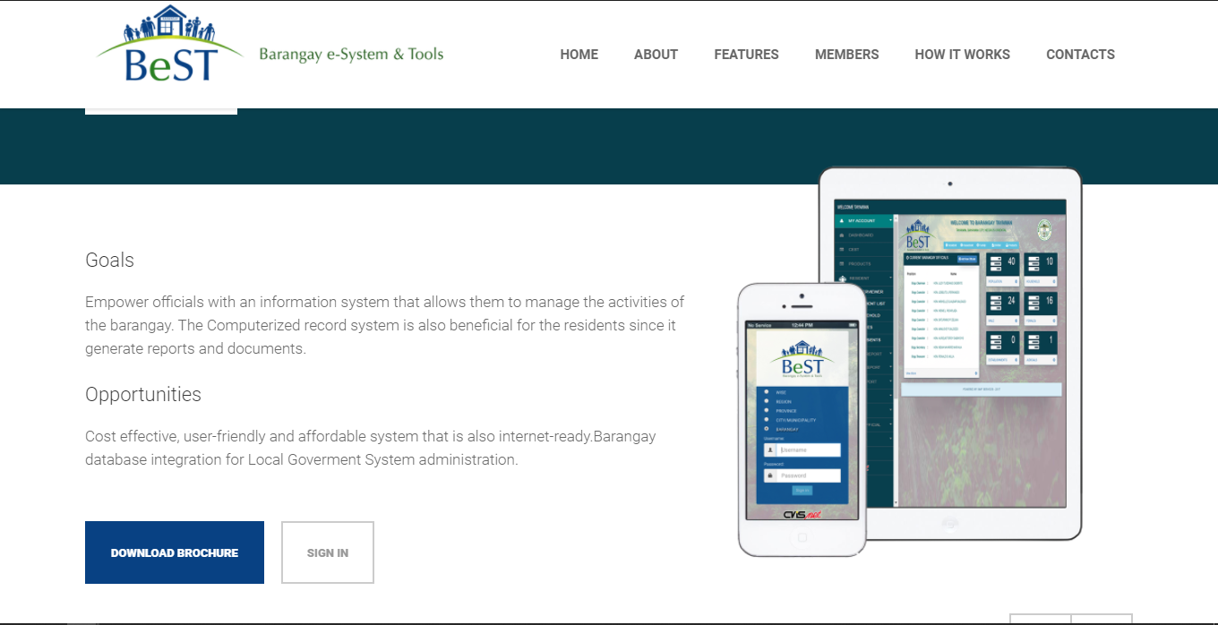

Figure 1**: BeST Barangay System**

BeST is a Barangay e-System that provides tools that can aide the needs to operate. This system boasts a management system for Records electronically; Information Management System for their Residents Profile, Judicial and Disaster Risk Reduction; and a Document Processing module that helps with Residents barangay clearance, Barangay ID, Business permits and transaction reports.

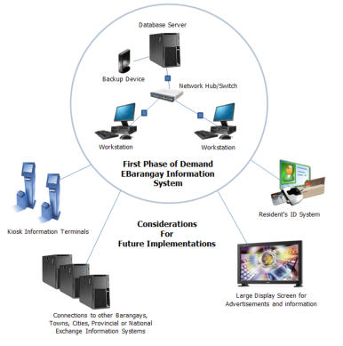

Figure 2: **e-Barangay visual of their functionality**

The objective of OnDemand eBarangay Information System is to organized local barangay information into a media where information becomes readily available and accessible upon demand or request.  Since local information cannot just be acquired anywhere, the need to build the information in electronic format is required.  Guidelines and procedures are in place in order to attain this objective.  History and previous information together with the current events and other information that is shared publicly will be encoded or scanned and saved in the system.  Logged books can still be in used and information is updated in the system.  Thus, a dictionary or encyclopaedia will be created and continuously updated as reference for current and future times.  The contents of the eBarangay Information System will be a legacy for the future generations.

Building of information from the barangay level is a better way to create a database of residents' information.  Barangay database can be linked or shared to a bigger database system where selected information is made available to the public.  Information from the barangay can be scaled to municipality, provincial or event national

Having online information for the locality offers a lot of benefits not only to the local constituents but to visiting guests and future generations.  Information can be used to create statistics, a tool for progress and event in the management of the local barangay. Partner eBIS with and ID system where unique number is assigned per individual can help crime prevention or event offers job opportunities to individuals where mix and match search can be requested.

|  |  |  |  |
| --- | --- | --- | --- |
|  | BeST | WarpVision ISS | eBarangay |
| Create Account | **✓** | **✓** | **✓** |
| Manage Account | **✓** | **✓** | **✓** |
| Manage Complaints |  |  | **✓** |
| Manage Requests |  |  | **✓** |
| Request Documents | **✓** | **✓** | **✓** |
| Profiling | **✓** |  | **✓** |
| Purok Integration | **✓** |  | **✓** |
| Public eBoard |  |  | **✓** |
| Schedule Activities |  |  | **✓** |
| Geographical View |  |  | **✓** |
| Create Organization/Groups |  |  | **✓** |

Table 1: **Comparative Matrix**

**CHAPTER III - RESEARCH METHODOLOGY**

**Scope and Limitations**

This study focuses on developing a web and mobile-based platform for barangay management system. This system will help barangay users manage resident records, complaints, reports, and barangay services. In addition, residents can receive notifications and be able to use the barangay services. This study will be first conducted here in Mandaue City.

The limitations of eBarangay are the following:

● The system cannot verify if the details inputted by the residents for their profile is accurate.

● The system will not handle the management of organizations.

**●** The system will only cater document requests for Barangay clearance, and Cedula.

**●** The system will only handle complaints and requests regarding lights, roads, residents, electricity, and water.

**●** The proposed study will only focus on barangays that are situated within the Mandaue City area.

● The system is not compatible with IOS.

● Android 4.0.3 and higher for Mobile devices.

● Windows 7 and higher for desktop/web.

**Software Engineering Methodology**

Software Engineering Methodology is a series of systematic process used in software projects. It comprises features of either building in a sequence, refining of current versions or tweaking of the system.

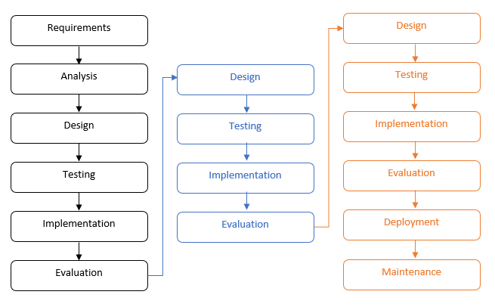Iterative model design is a particular design that is broken down into iterations. It starts with the requirements where system related information is gathered and analyzed. Then the design phase is next, to utilized the design of the system. After that is the implementation phase, coding process is involved and executed from the designs and specifications to implement the initial iterations. Testing phase will then be done to test the code that was implemented. This is to identify and locate potential bugs and issues. Evaluation is the final phase of the iterative model design. This is to examine the project status and validate the initial requirements as well as the suggestions for the next possible iteration.

**Figure 3: Iterative Model – Design**

The researchers chose waterfall model design as this method will help them collect, evaluate, and process each phase carefully and steadily. The researchers plan to develop the system in a step-by-step process, until the features and goals of each phase are completely delivered as this method helps the researchers identify the problems that might arise in the future, and will intend to fix it beforehand.

**Planning Phase**

**Business Model Canvas**

Business Model Canvas is a strategic management and lean startup template for developing new or documenting existing business models. It is a great tool to help us understand a business model in a straightforward, structured way. It is a visual chart with elements describing a product’s value proposition, infrastructure, customers, and finances

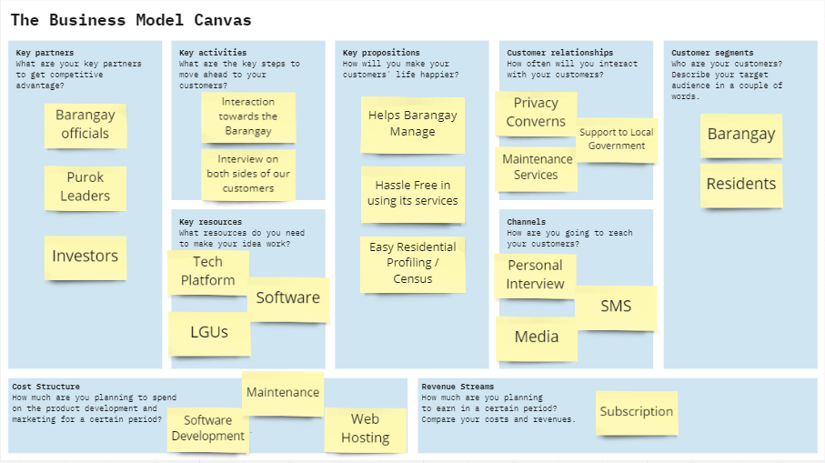

Figure 4: **Business Model Canvas**

The figure above is the business model canvas used by the eBarangay. There are two customer segments involved: Barangay and Residents. As for Residents, they need to register in order to gain access to the services, while Barangay users will have their accounts be created by the admin. The revenue streams rely on the subscriptions from barangays who want to use the system, and service charges from every document requests.

**Program Workflow**

A program workflow is a demonstration of an application that represents a step-by-step process of software that is executed accordingly.

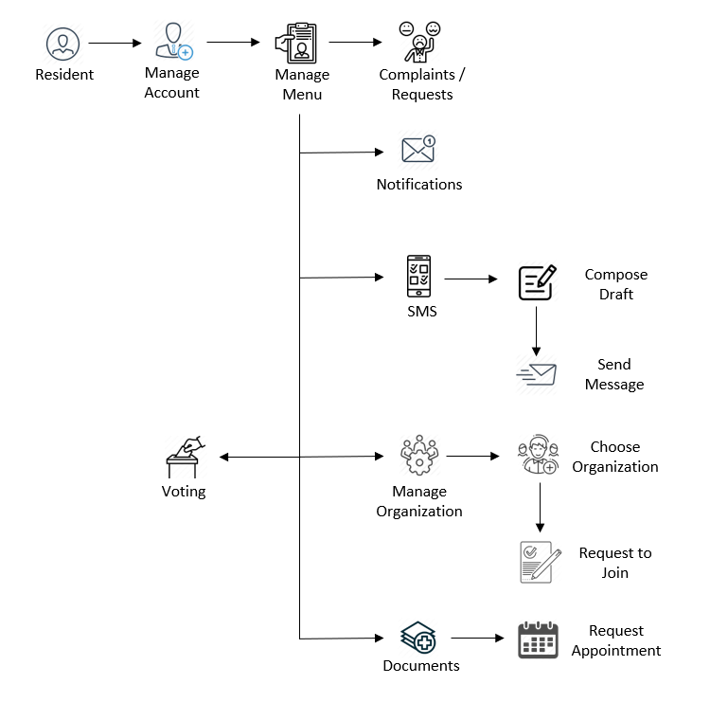

Figure 5: **Program Workflow – Resident**

The Residents can send complaints and requests to the purok. They can also manage their notifications to either receive or send them. They can also manage SMS or short message services, mostly towards the assigned purok. They can also manage the barangay organization they are in. They can also manage documents like asking for requirements or asking for the documents itself with the request of appointments. They are also able to see the nominees of the purok in their area and vote for them.

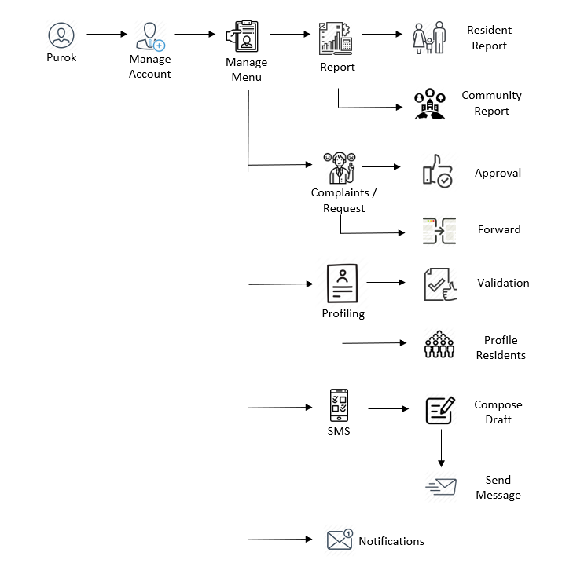

Figure 6: **Program Workflow – Purok**

The Barangay Purok can manage reports of the residents under them or the assigned community in general. They can also manage the complaints or request of their residents for approval or to forward them if deemed unable or level of complaints and request is out of their authority. They can also manage SMS or short message service with their assigned residents. Lastly would be to manage profiling residents. They can validate if the information of the residents is authentic or not, and they are also able to record non-users that are unfortunate to neither have internet nor the device for residents to use.

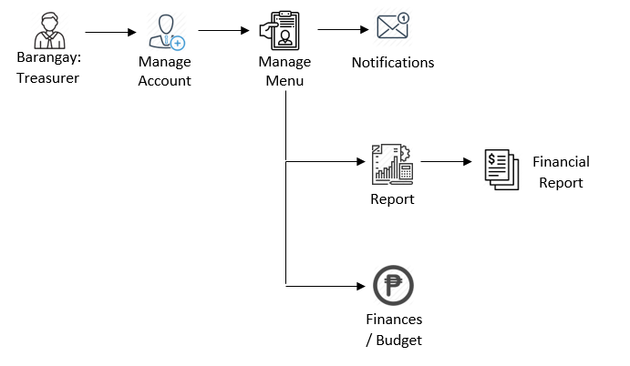

Figure 7: **Program Workflow – Treasurer**

The treasurer mostly handles the finances of the barangay, so anything that concerns money like their budget, collecting and issuing official receipts for taxes, fees, contributions materials and other resources that is used and deposited in the account of the Barangay. The user will also send out reports according to all the records they collected and estimated incomes or expenditures for the preceding and ensuing time.

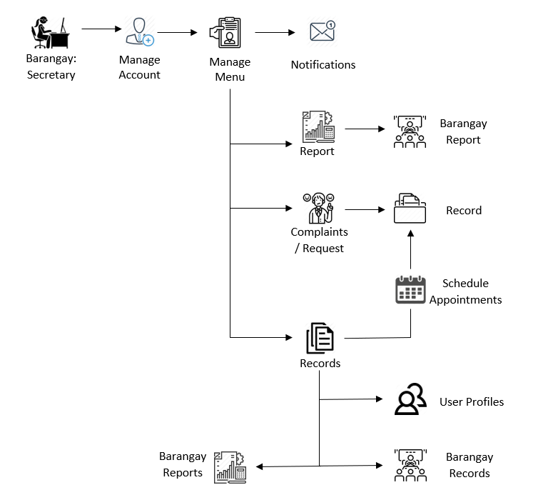

Figure 8: **Program Workflow – Secretary**

The Barangay Secretary receives notifications from multiple people, from the residents to the barangay captain. The user receives complains, requests, reports and profiles for them to record. The user can also set appointments to the requests and the complaints of their residents. The secretary also handles posting some of the announcements depending on the barangay captain.

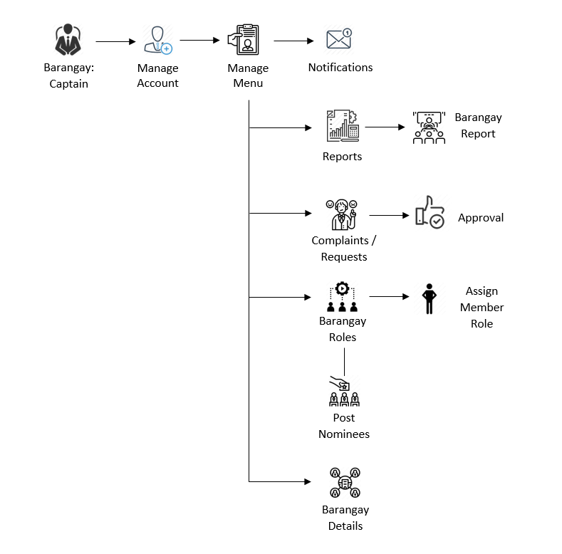

Figure 9: **Program Workflow – Captain**

The figure above demonstrates the function of the system towards the Barangay Captain users. The user can manage to either receive or send notifications. Managing reports is also available to the user. It can also manage approvals of complaints and request that are forwarded from the purok leaders. The barangay captain also handles the barangay roles where he can assign the roles of the users that he wants to choose for the secretary and the treasurer. It an also manage to post nominees of the different purok leaders for the residents to vote for.

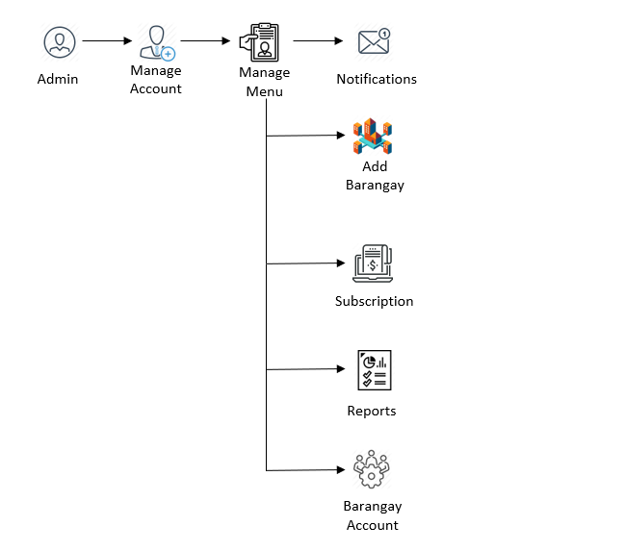

Figure 10: **Program Workflow – Admin**

The figure above is the program workflow for the admin. The admin can manage notifications, barangay details, subscriptions and reports. The admin can also manage the barangay account wherein the account is given to the role of the captain.

**Gantt Chart**

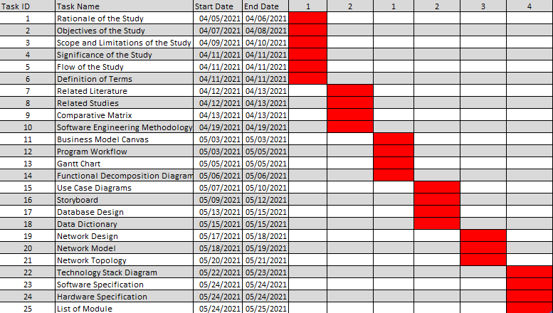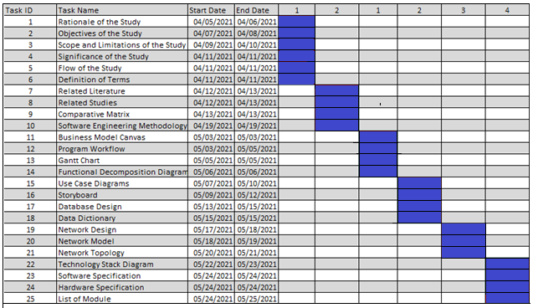These is the Gantt chart of the researchers which shows the amount of work done or production completed in certain periods of time in relation to the amount planned for those periods.

Table 2: **Capstone 1 Gantt Chart: Projected**

Table 3: **Capstone 1 Gantt Chart: Completed**

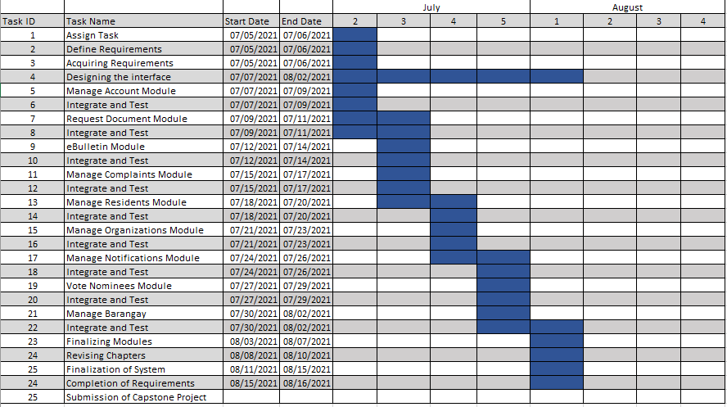

**Functional Decomposition Diagram**

Table 4: **Capstone 2 Gantt Chart: Projected**

Functional decomposition is defined as a top-down representation of process or function. The Functional Decomposition Diagram shows that there are eight managements which are: Services, Profiling, Accounts, Information, Organization, Complaints, Barangay, and Voting. These managements can be accessed by varied users. The legend shows you which functionalities are accessed by whom. Basically, this is used for representing business function and operation in hierarchical manner.

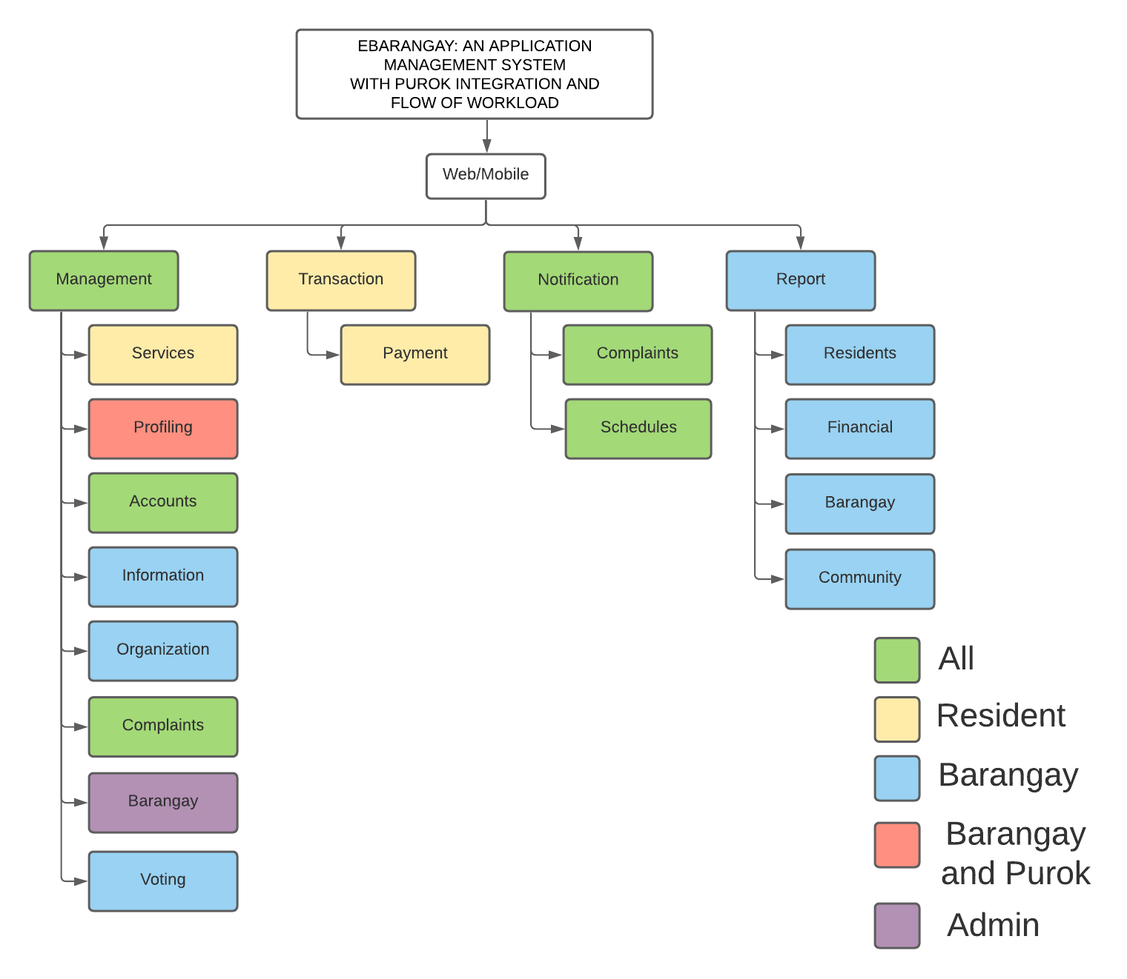

Figure 11: **Function Decomposition Diagram**

**Analysis Phase**

**Use – Case Diagram**

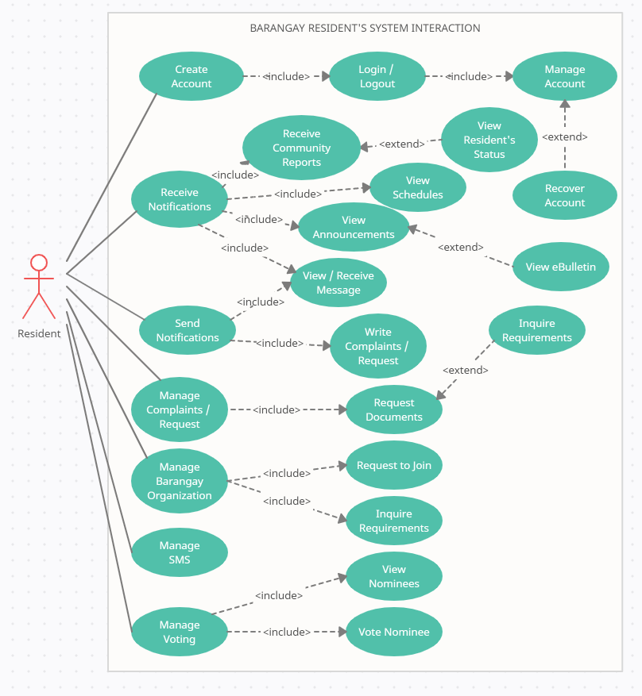

Figure 12: **Use Case – Barangay Resident**

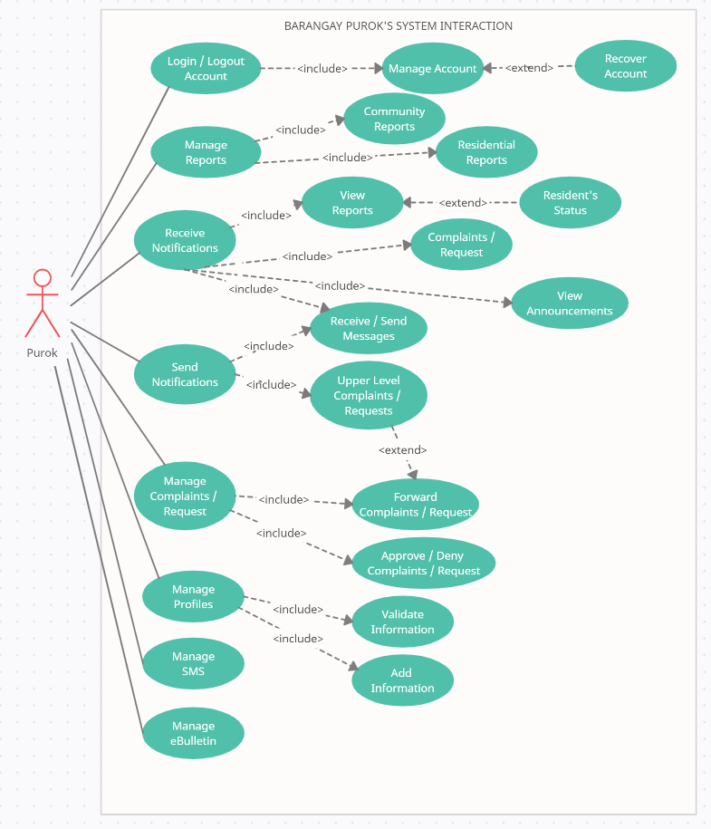

Figure 13: **Use Case – Barangay Purok**

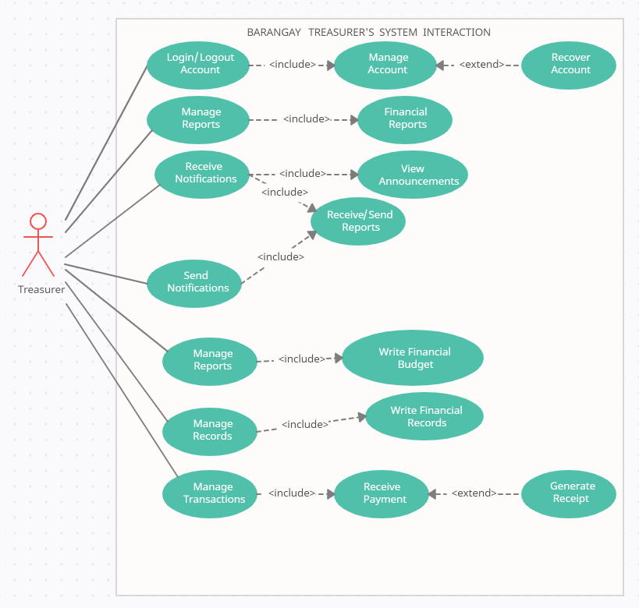

Figure 14: **Use Case – Barangay Treasurer**

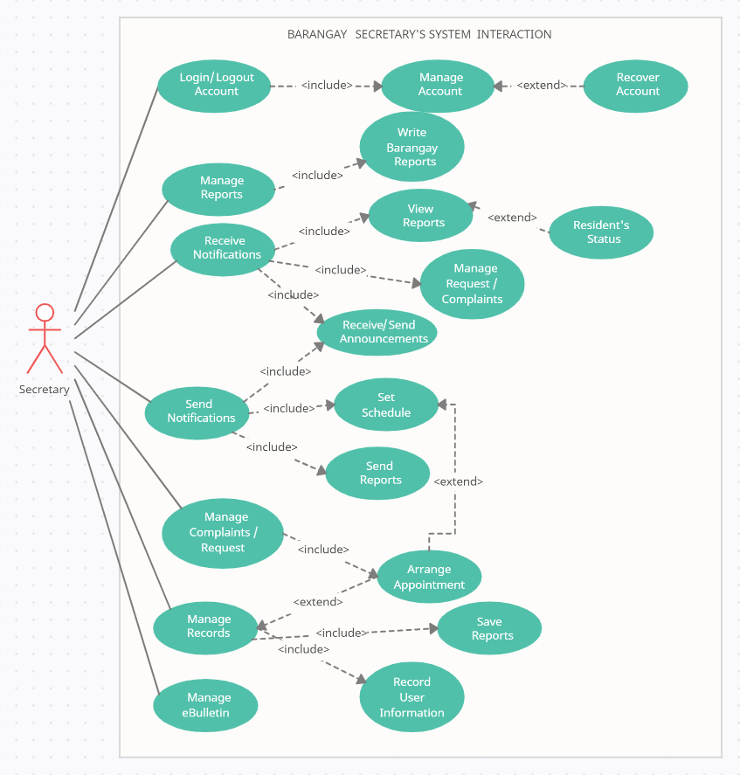

Figure 15: **Use Case – Barangay Secretary**

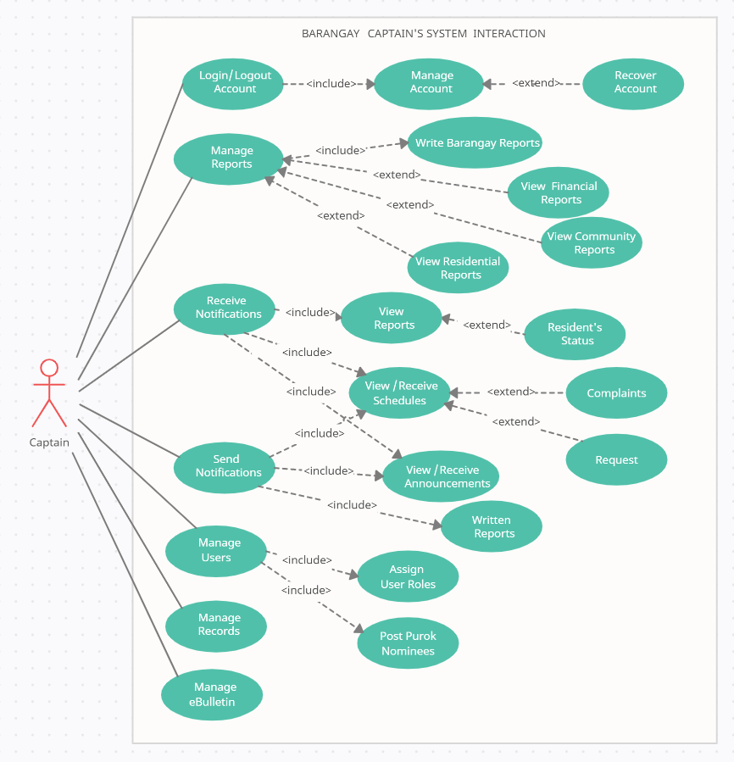

Figure 16: **Use Case – Barangay Captain**

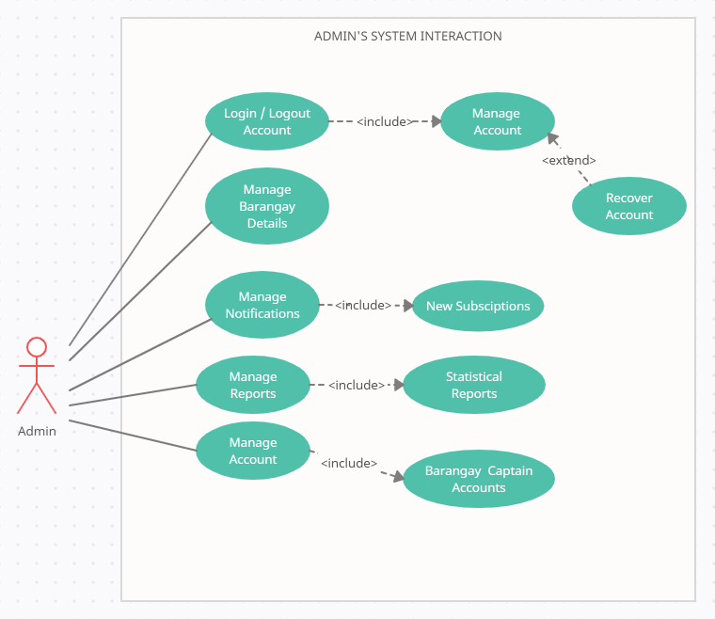

Figure 17: **Use Case – Admin**

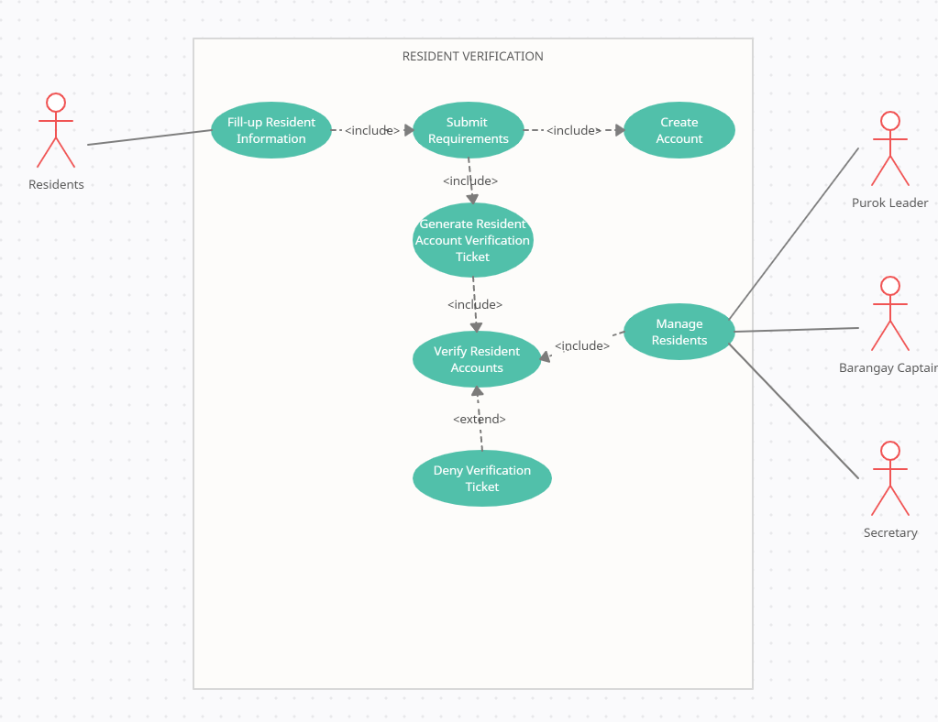

Figure 18: **Use Case – Resident Verification**

**Storyboard**

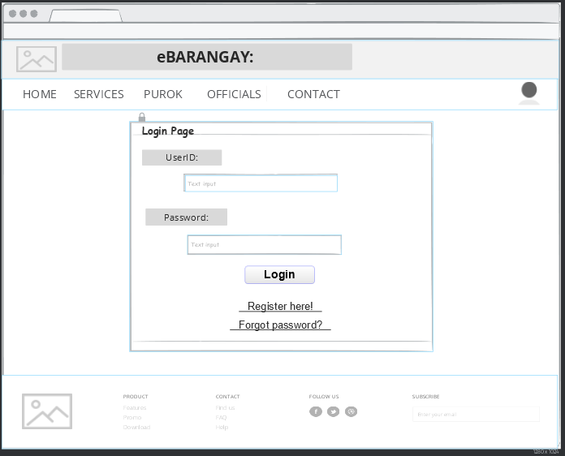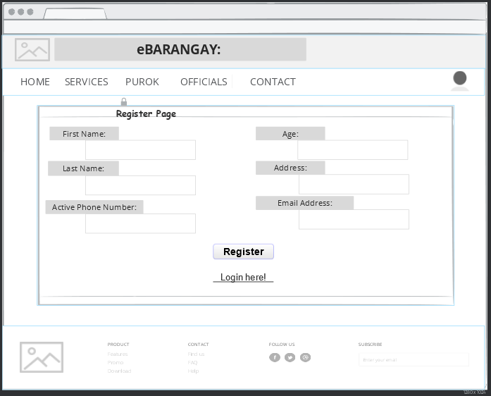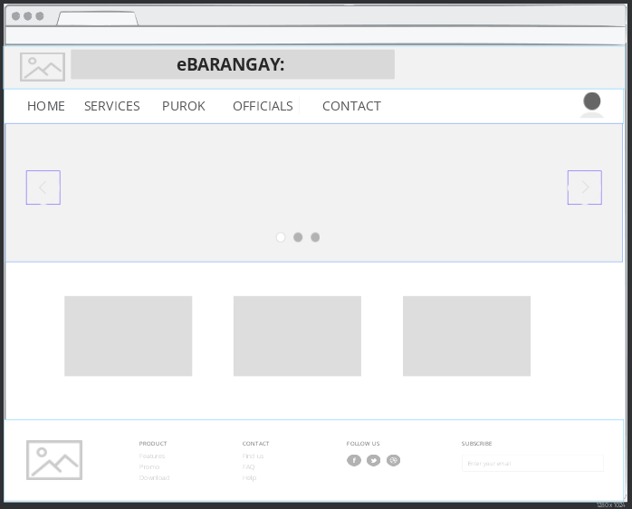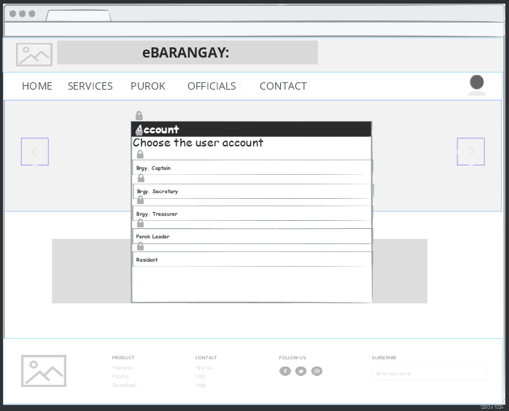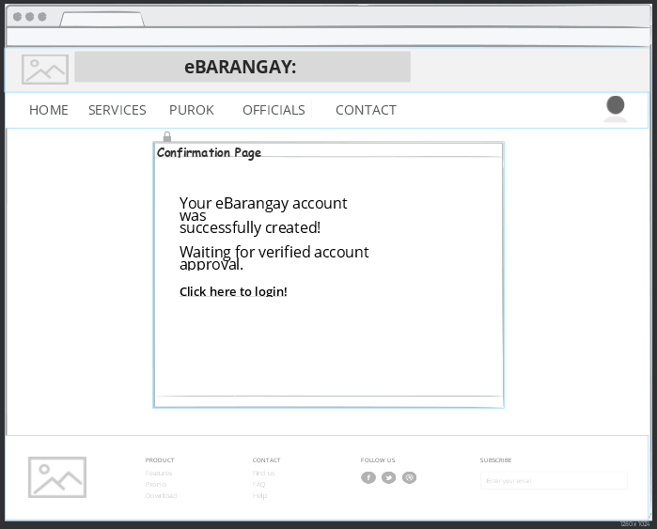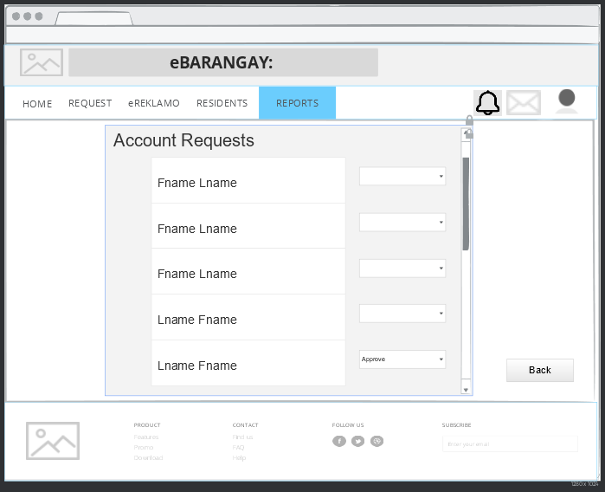Web

Figure 19: **Storyboard – Webpage - Homepage**

Figure 20: **Storyboard – Choose Account**

Figure 21: **Storyboard – Register Page**

Figure 22: **Storyboard – Login Page**

Figure 23: **Storyboard – Resident Acc Request**

Figure 24: **Storyboard – Confirmation Page**

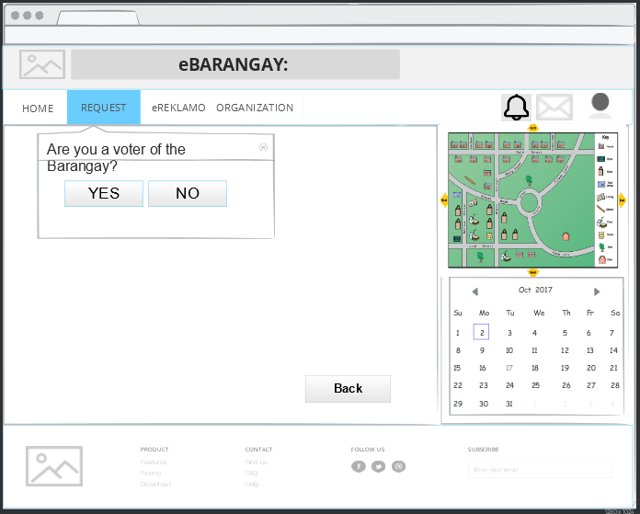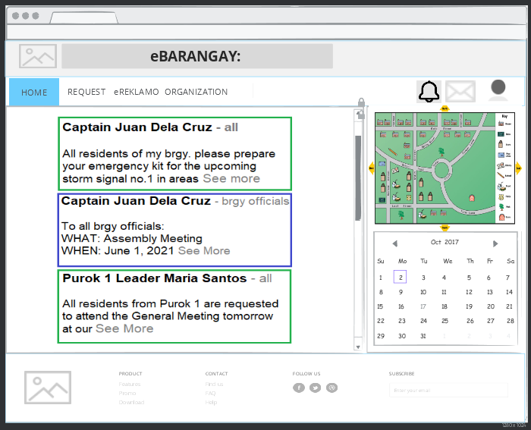

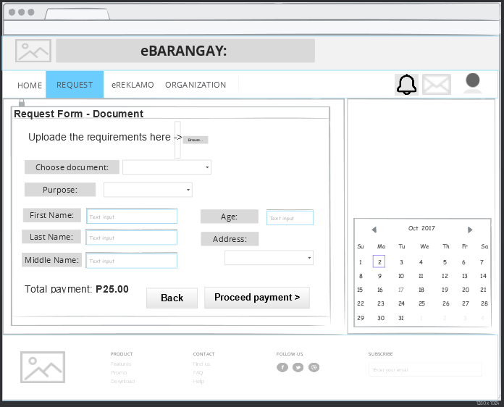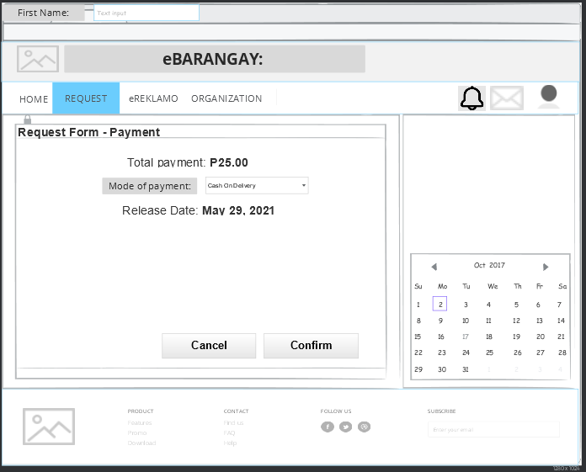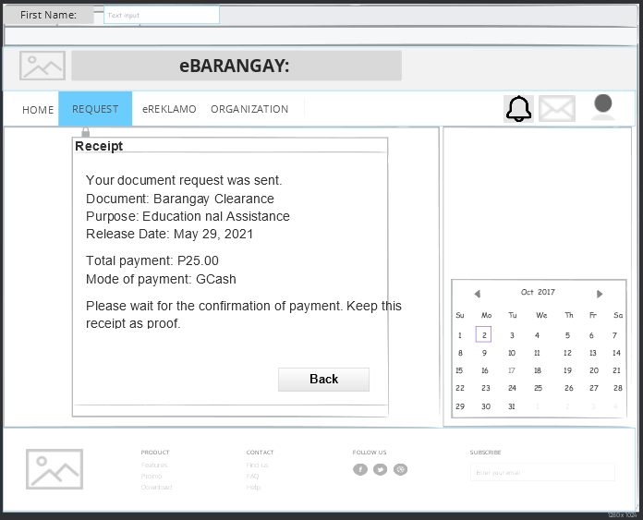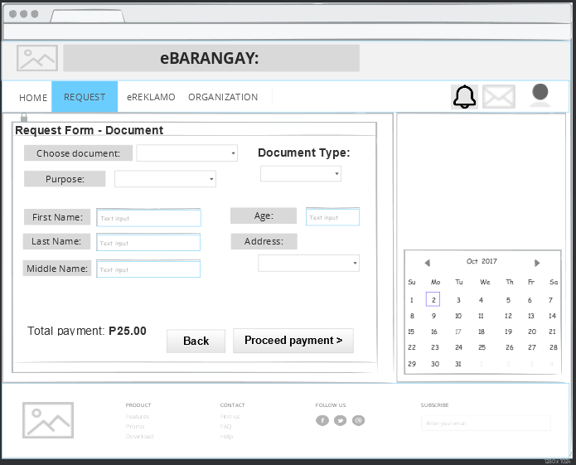

Figure 25: **Storyboard – Resident eBulletin**

Figure 26: **Storyboard – Request Prompt**

Figure 27: **Storyboard – Request Form**

Figure 28: **Storyboard – Payment Request Form**

Figure 29: **Storyboard – Receipt**

Figure 30: **Storyboard – Document Request Form**

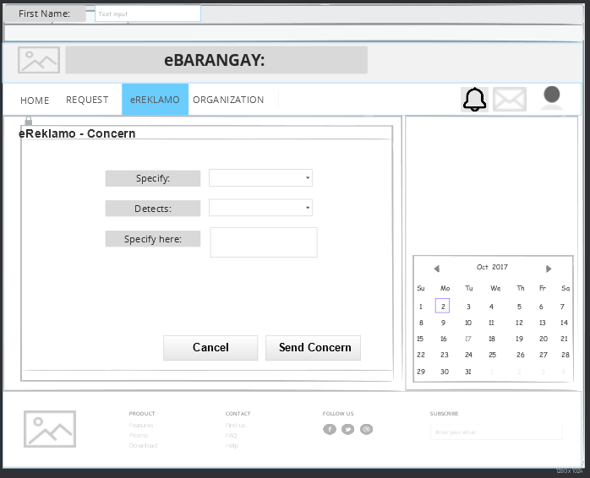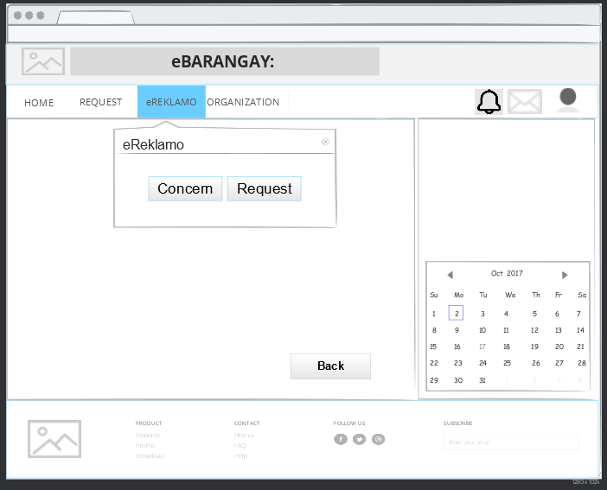

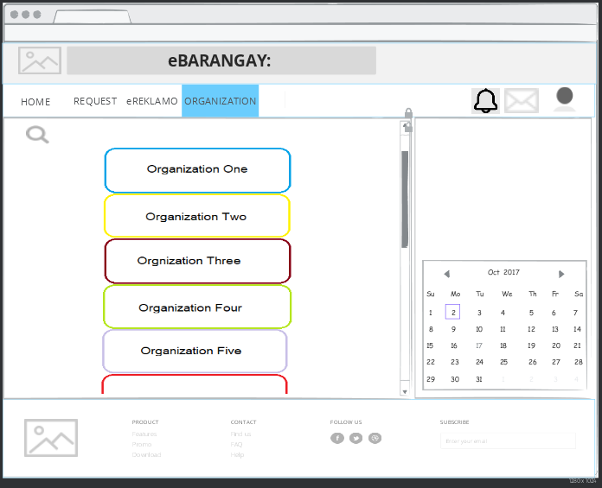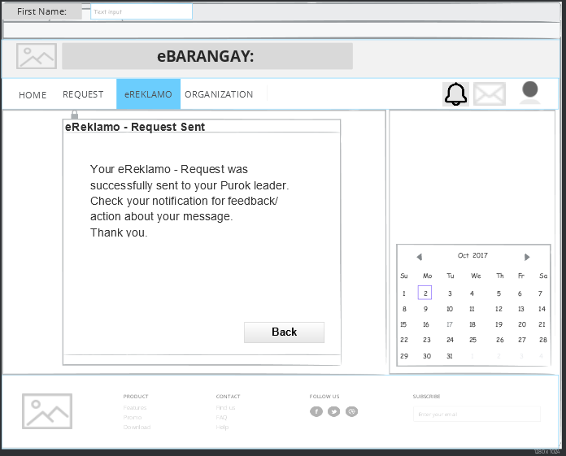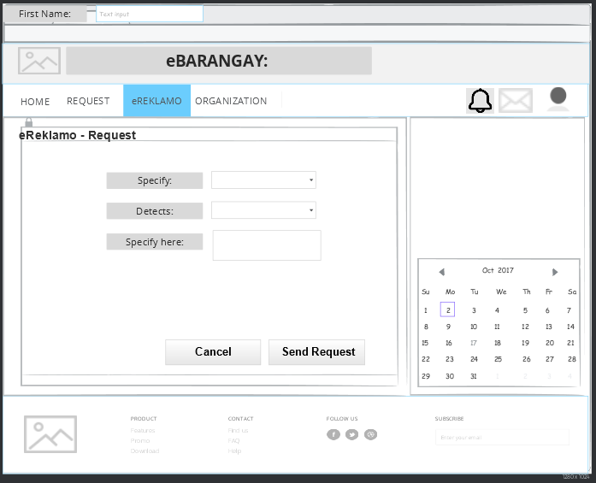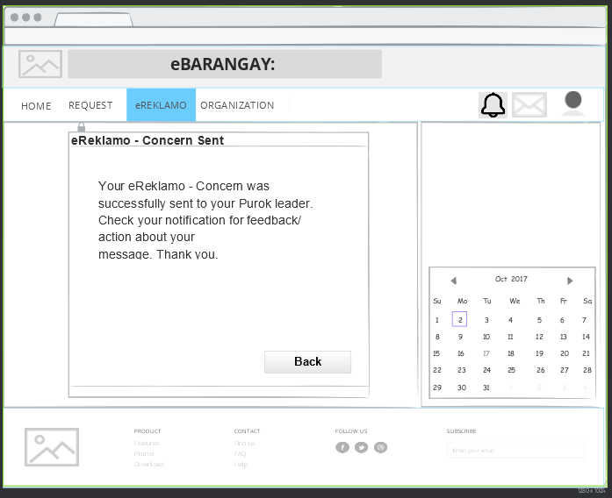

Figure 36: **Storyboard – Organization**

Figure 35: **Storyboard – Request sent**

Figure 31: **Storyboard – eReklamo prompt**

Figure 32: **Storyboard – Concern**

Figure 33: **Storyboard – Concern request sent**

Figure 34: **Storyboard – Request**

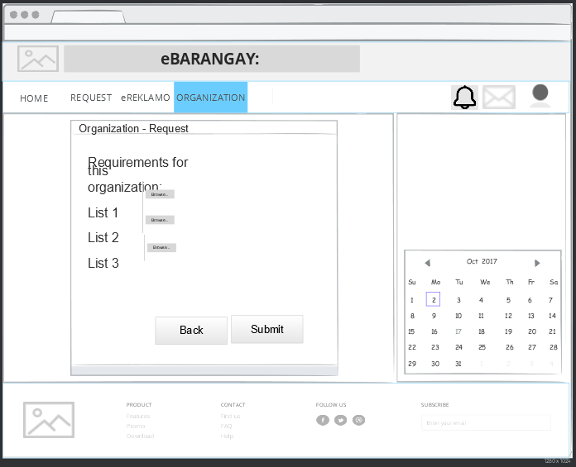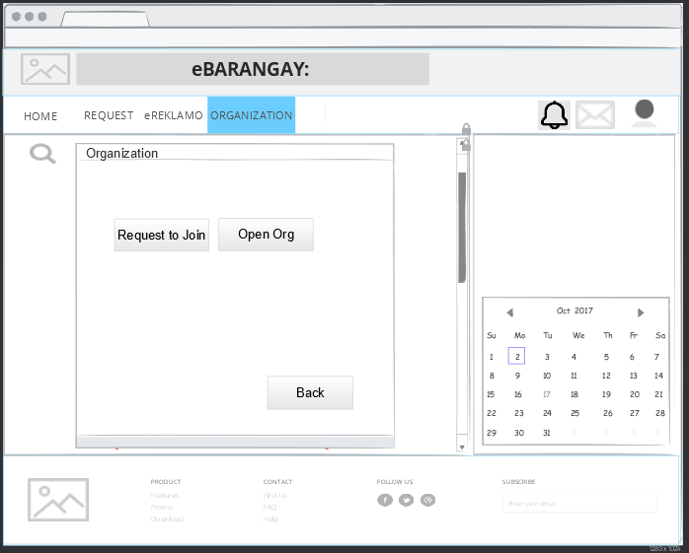

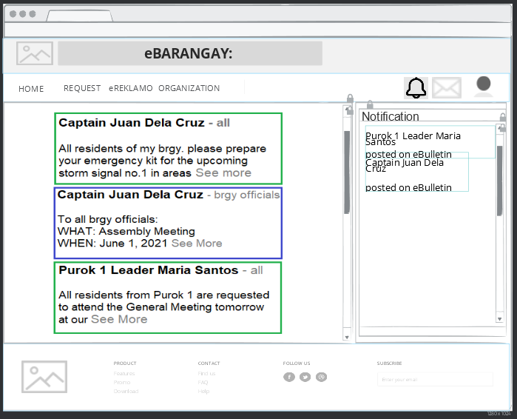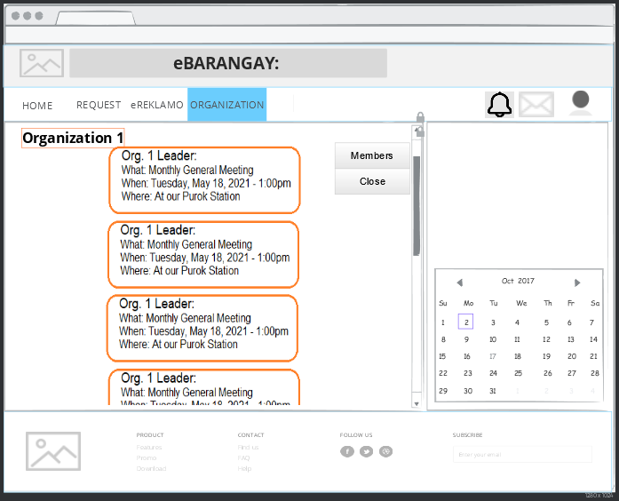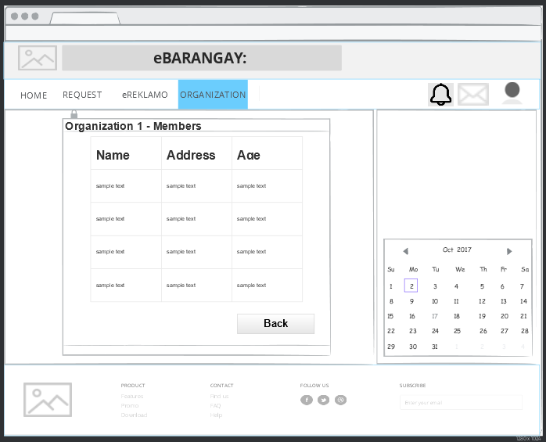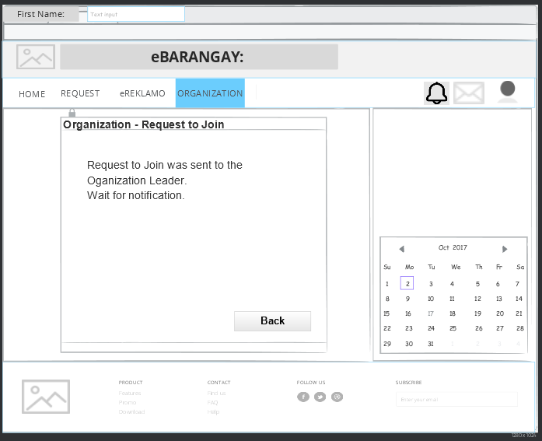

Figure 42: **Storyboard - Notification**

Figure 41: **Storyboard – Org Content**

Figure 40: **Storyboard – Org members**

Figure 39: **Storyboard – Join Request sent**

Figure 38: **Storyboard – Upload Requirements**

Figure 37: **Storyboard – Join Org**

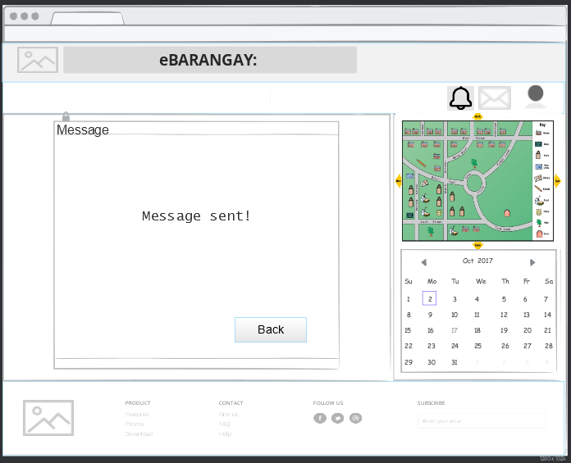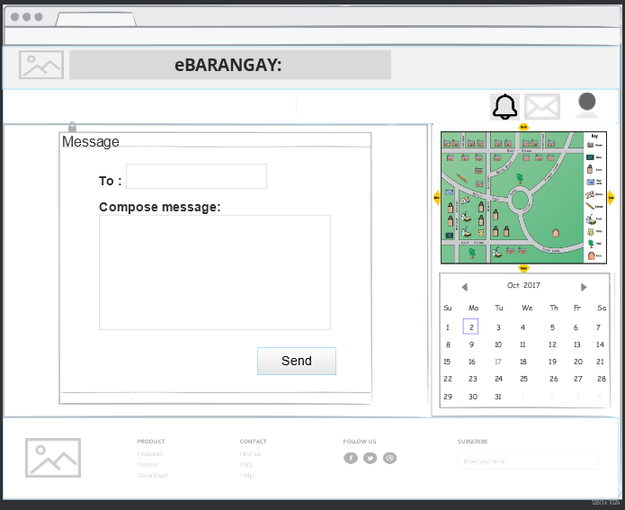

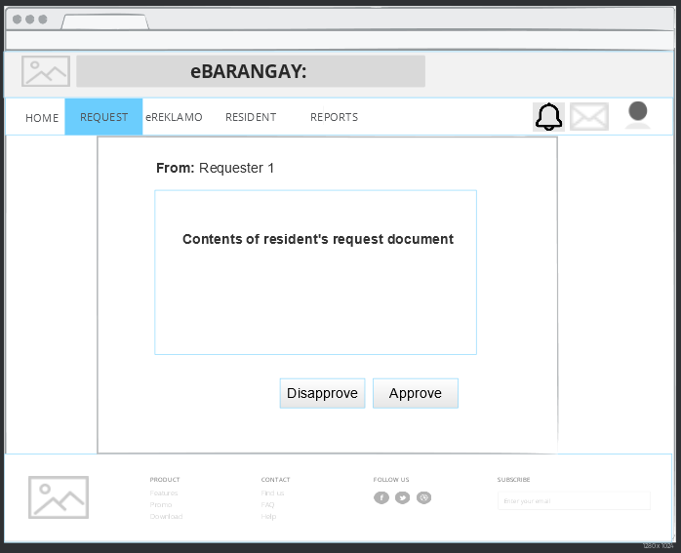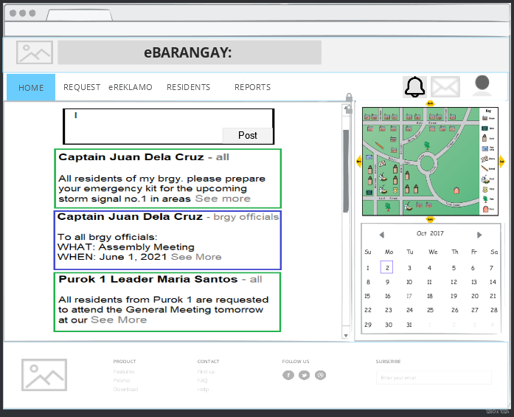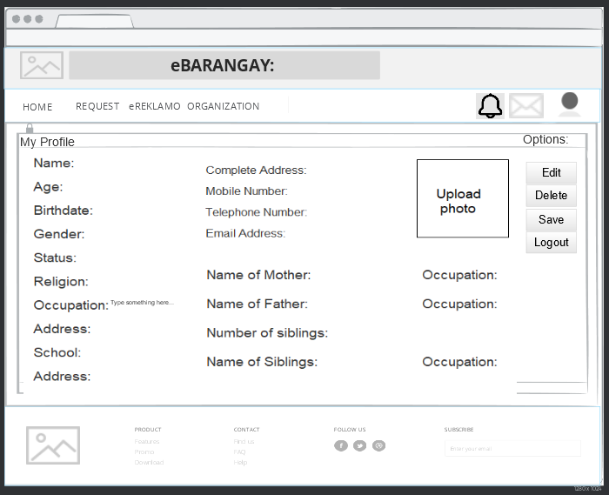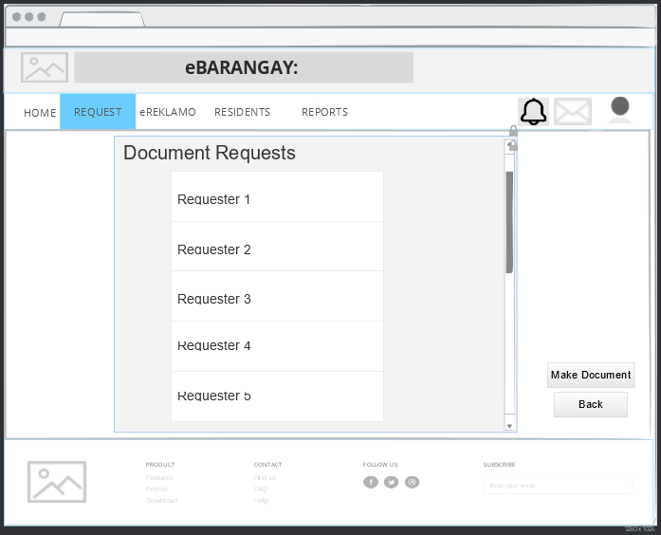

Figure 48: **Storyboard – Request content**

Figure 47: **Storyboard – Post content**

Figure 46: **Storyboard – My Profile**

Figure 45: **Storyboard – Document Requests (PUROK LEADER)**

Figure 44: **Storyboard – Message sent**

Figure 43: **Storyboard – Message Compose**

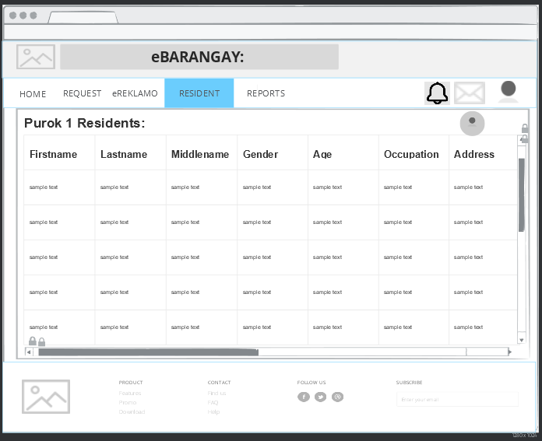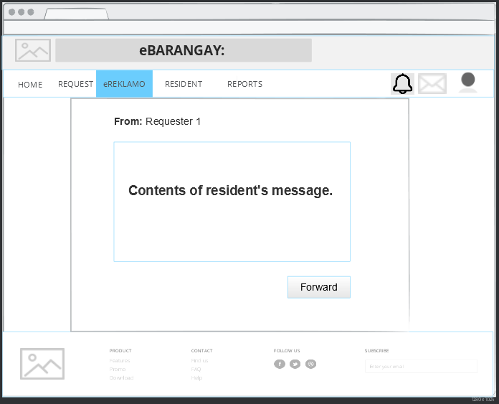

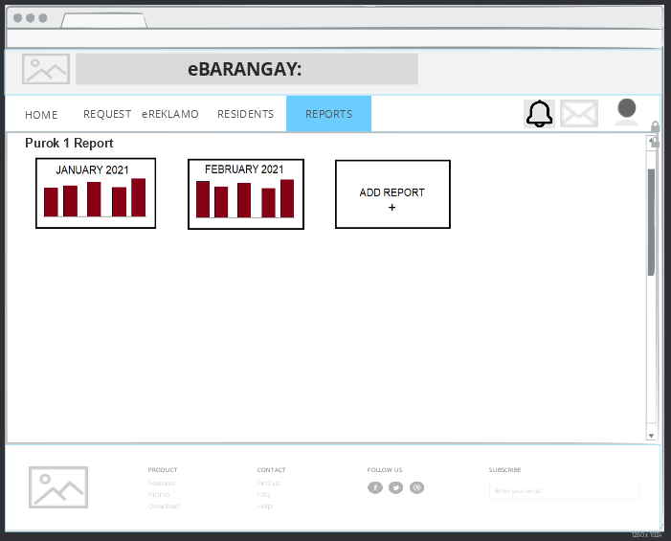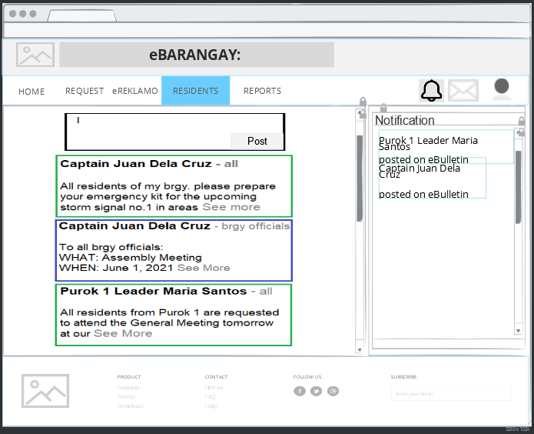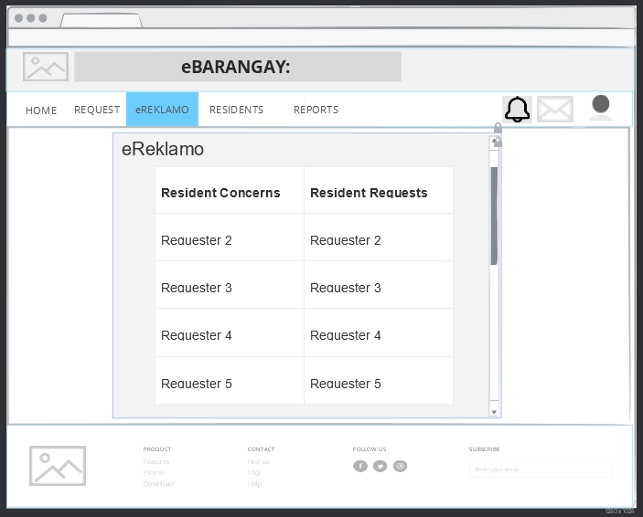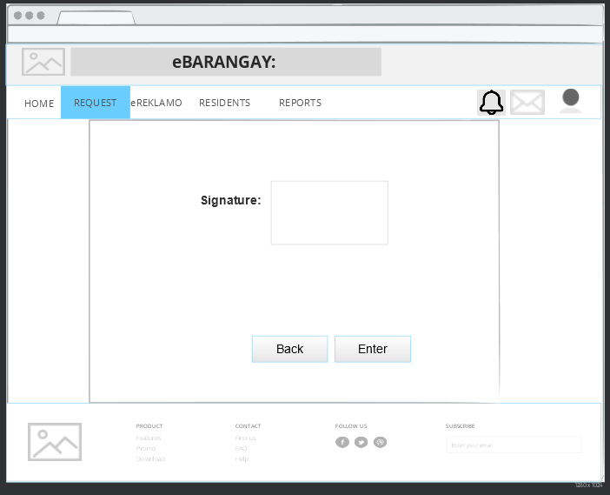

Figure 54: **Storyboard - Report**

Figure 53: **Storyboard - Notification**

Figure 52: **Storyboard – Request/Concerns info**

Figure 51: **Storyboard – Purok Leader Signature**

Figure 50: **Storyboard – Resident Info**

Figure 49: **Storyboard – Resident’s message**

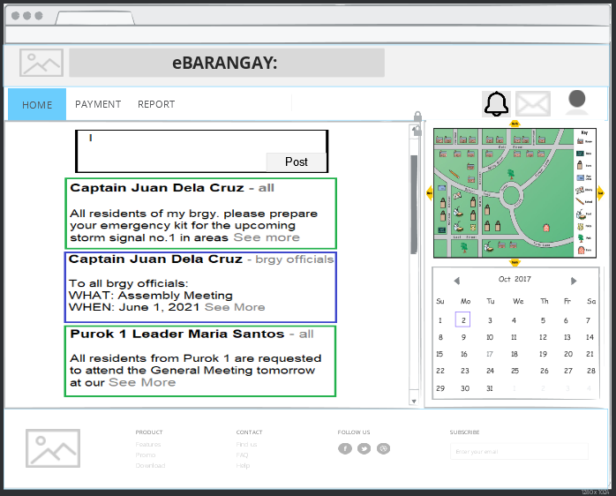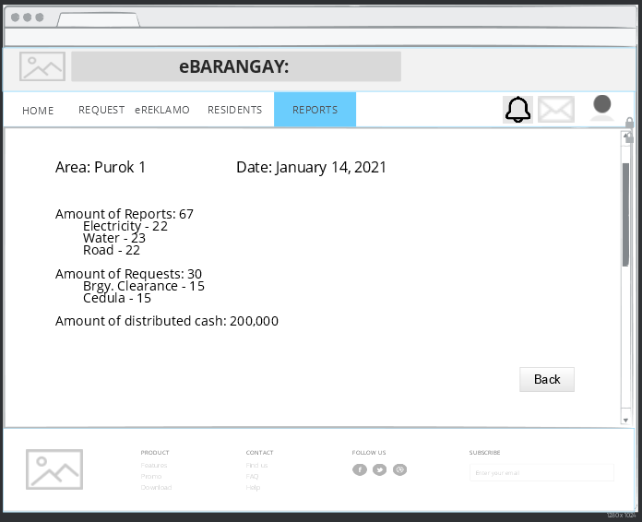

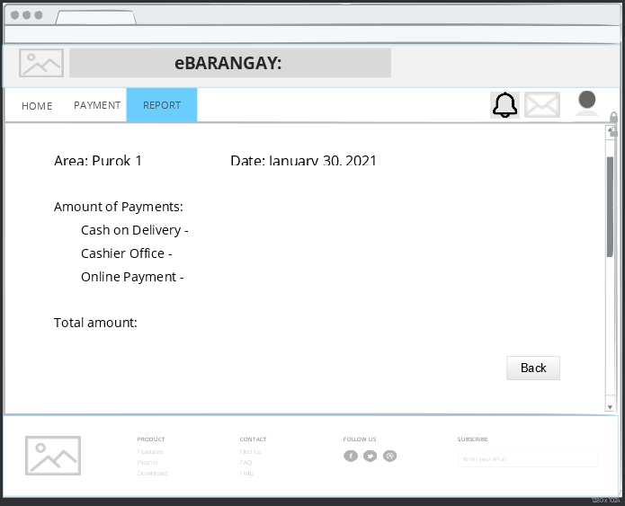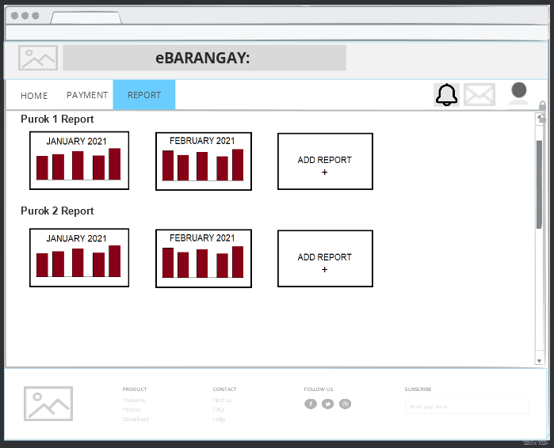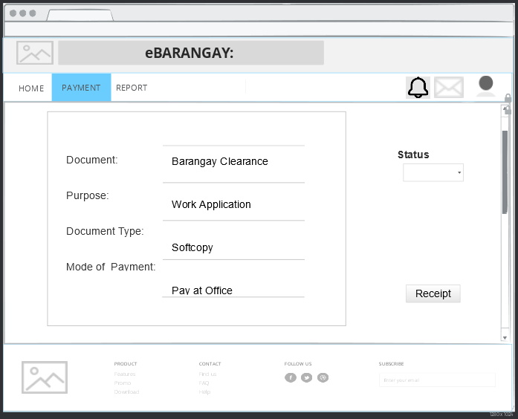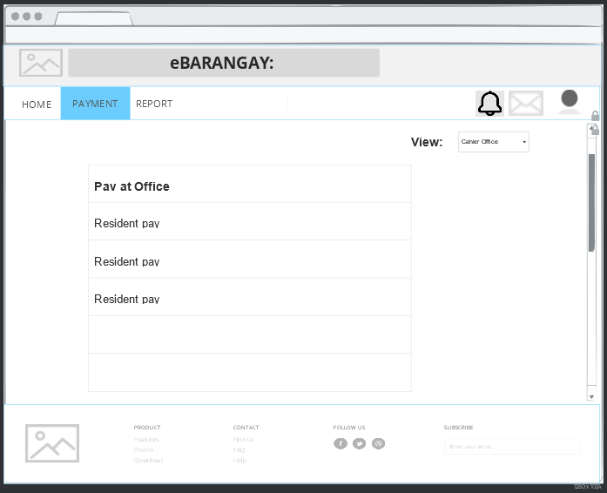

Figure 59: **Storyboard – Report**

Figure 60: **Storyboard – Report Content**

Figure 58: **Storyboard – Payment Details**

Figure 57: **Storyboard – Payment**

Figure 56: **Storyboard – Treasurer homepage**

Figure 55: **Storyboard – Report Content**

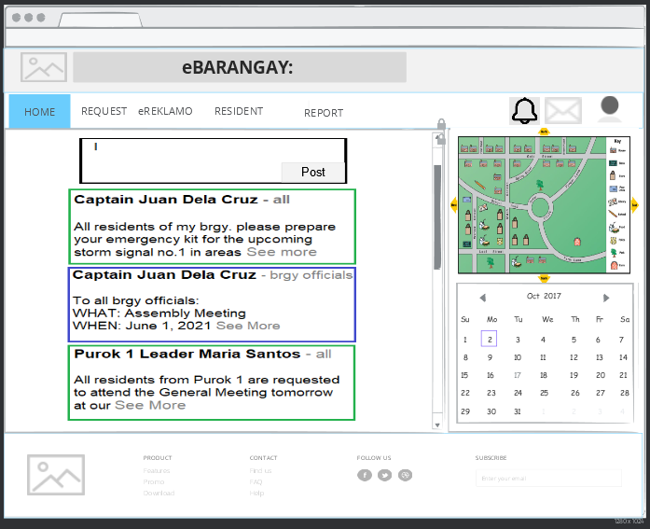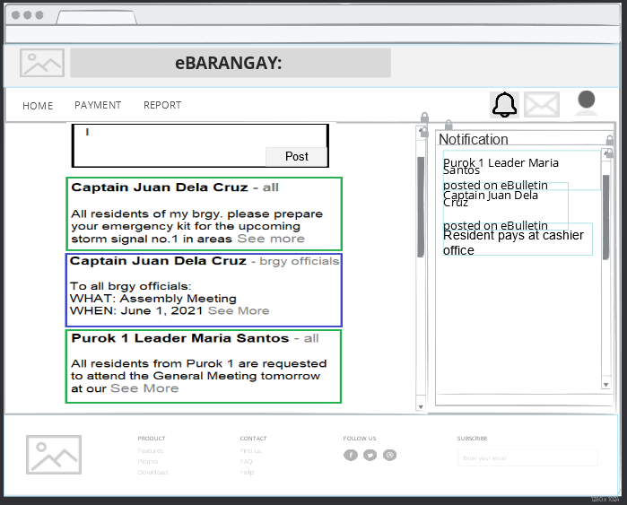

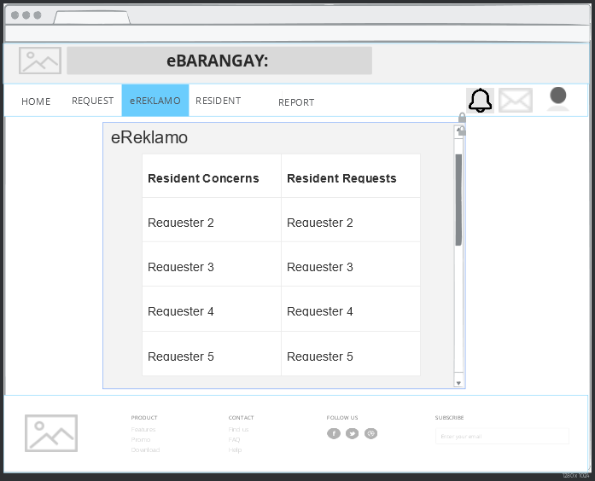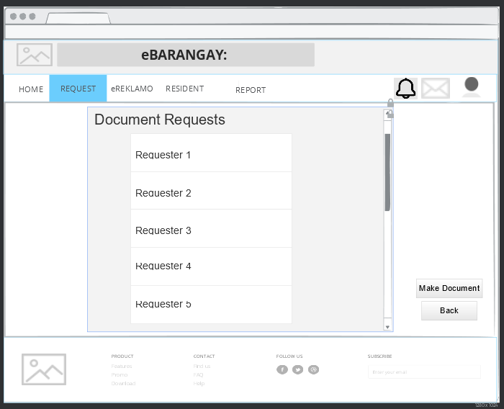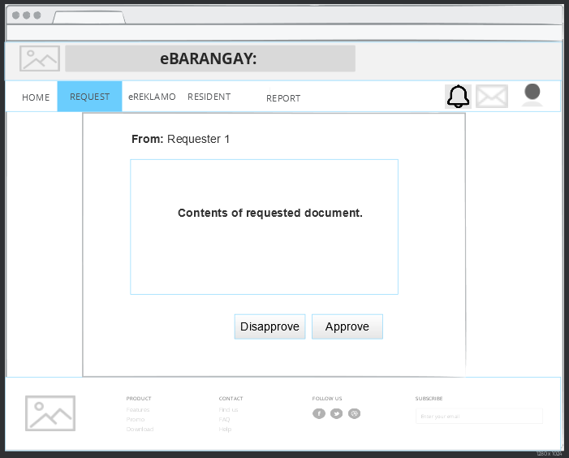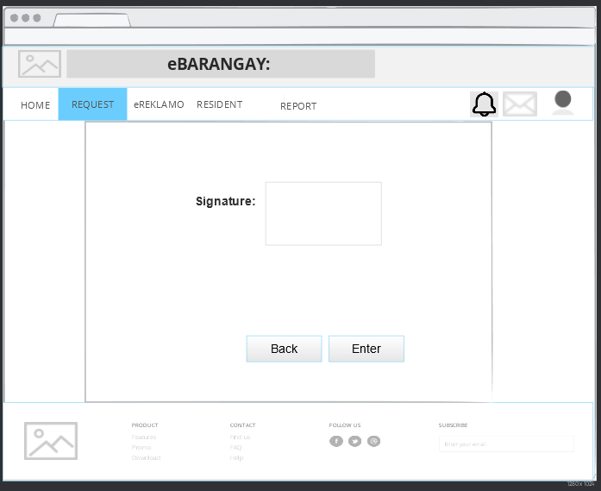

Figure 66: **Storyboard – Secretary eReklamo**

Figure 65: **Storyboard – Secretary request sign**

Figure 64: **Storyboard – Secretary request sign**

Figure 63: **Storyboard – Secretary request sign**

Figure 62: **Storyboard – Secretary homepage**

Figure 61: **Storyboard – Report**

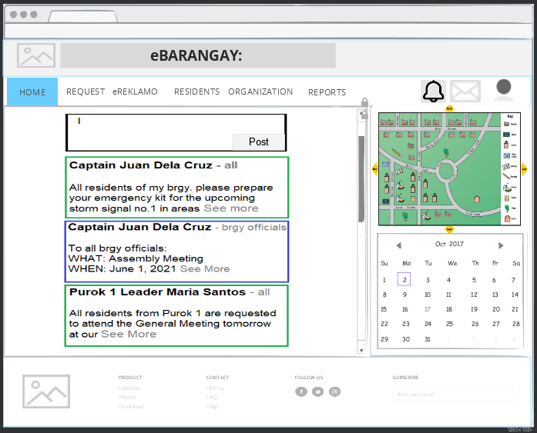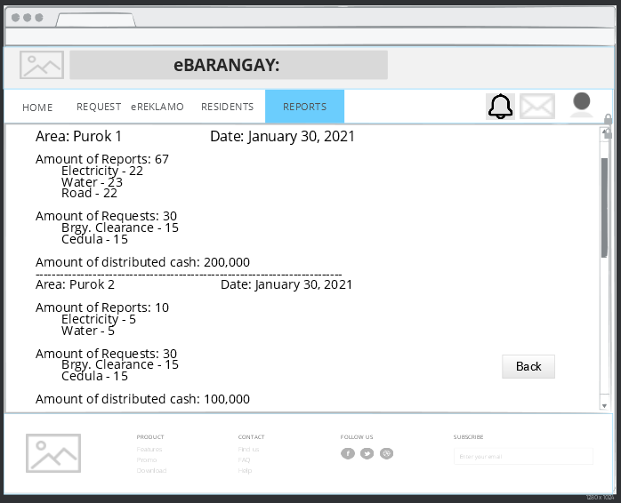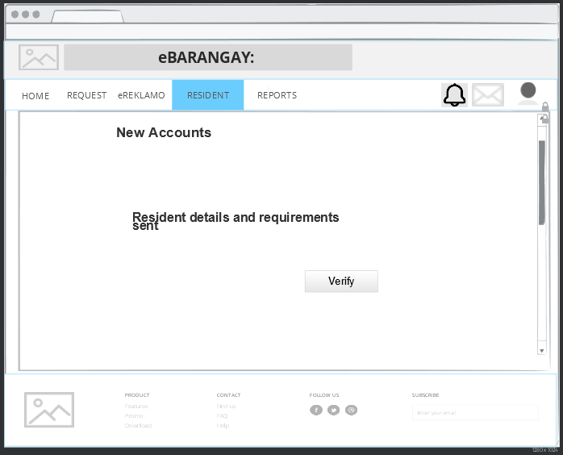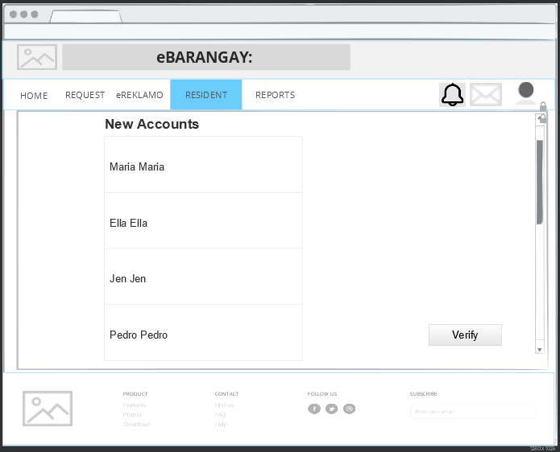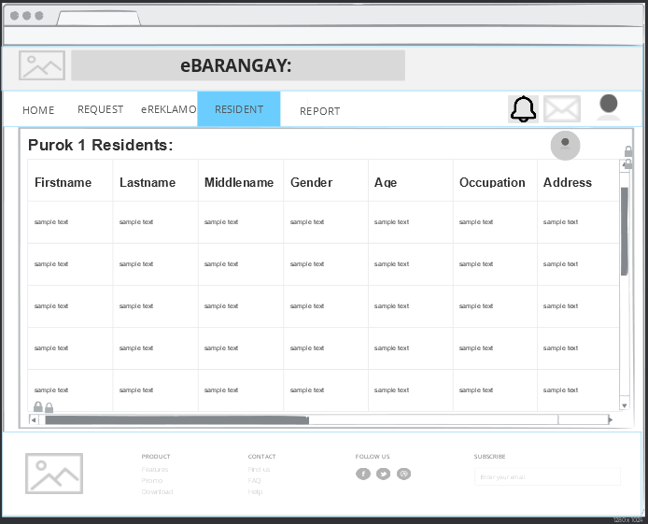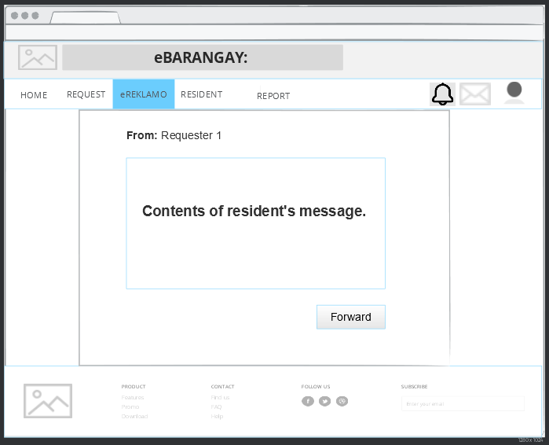

Figure 72: **Storyboard – Brgy Captain homepage**

Figure 71: **Storyboard – Report content**

Figure 70: **Storyboard – Account verification page**

Figure 69: **Storyboard – Secretary verify account list**

Figure 68: **Storyboard – Secretary residents**

Figure 67: **Storyboard – Secretary eReklamo content**

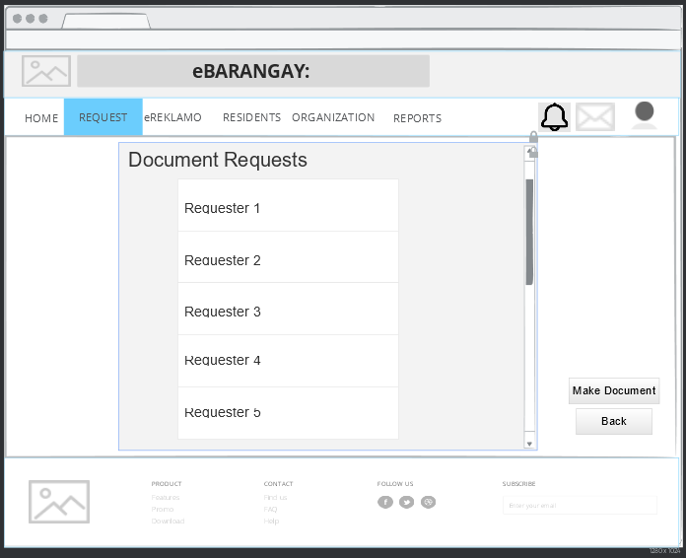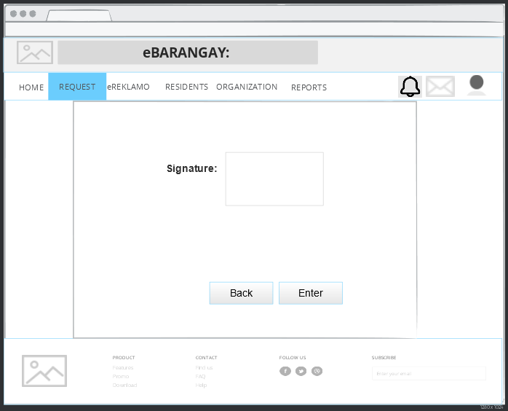

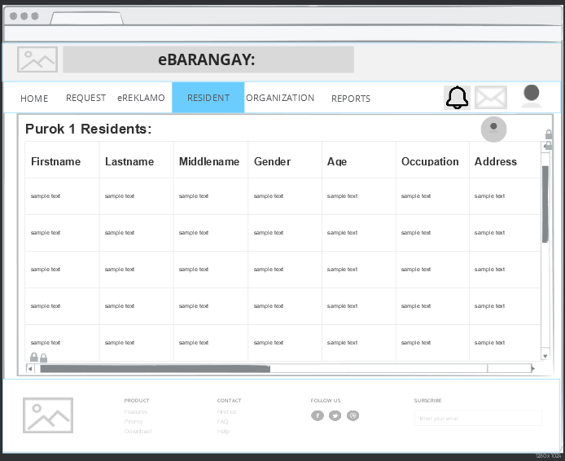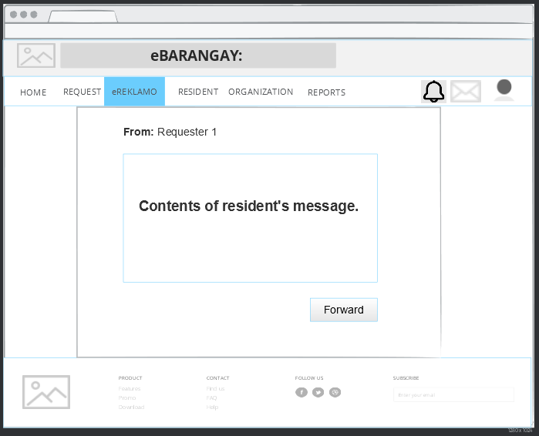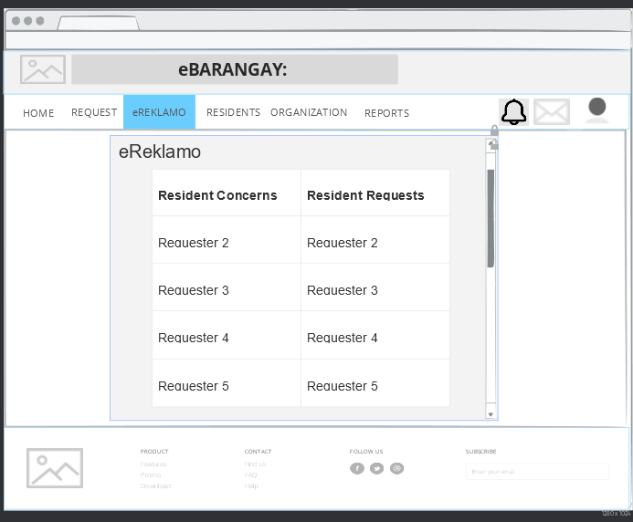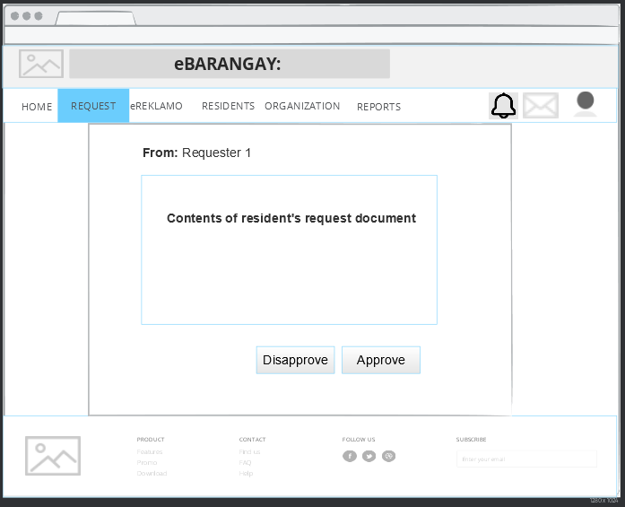

Figure 78: **Storyboard – Resident list**

Figure 77: **Storyboard – Resident’s message**

Figure 76: **Storyboard – Concern/Request list**

Figure 75 **Storyboard – Request content**

Figure 74: **Storyboard – Document requests**

Figure 73: **Storyboard – Signature requests**

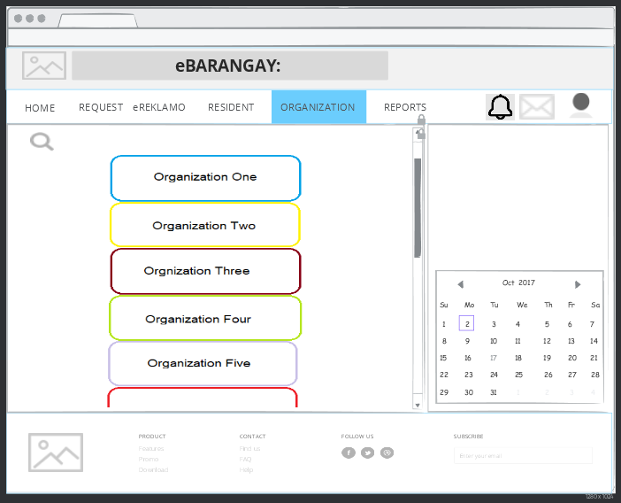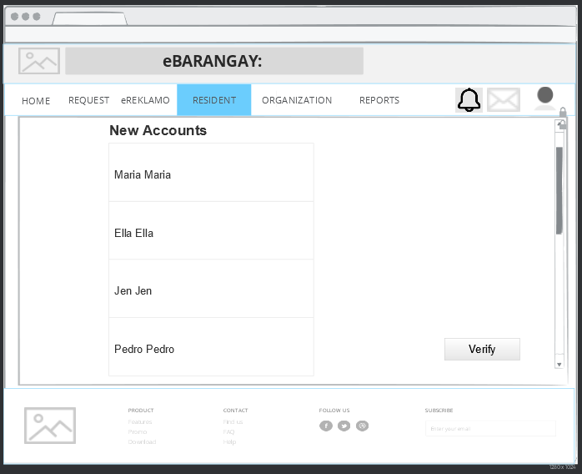

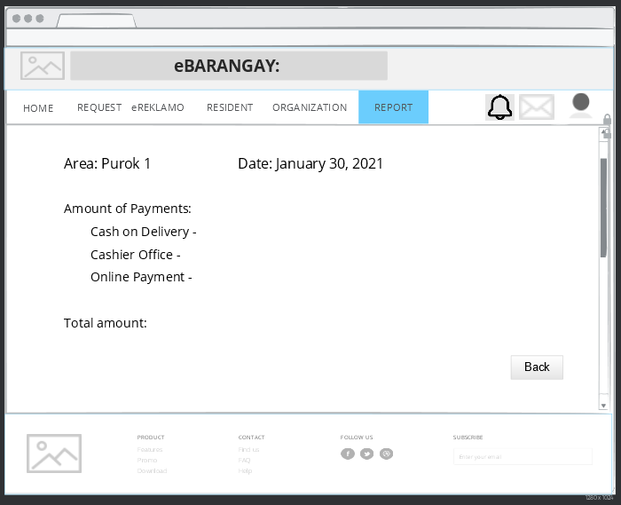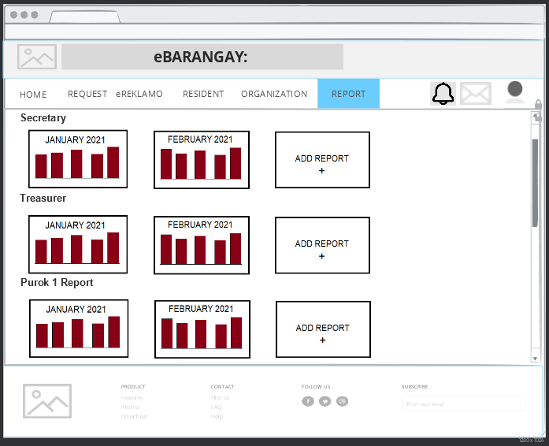

Figure 83: **Storyboard – Notifications**

Figure 82: **Storyboard – Report content**

Figure 81: **Storyboard – Reports**

Figure 80: **Storyboard – Organization**

Figure 79: **Storyboard – Resident list**

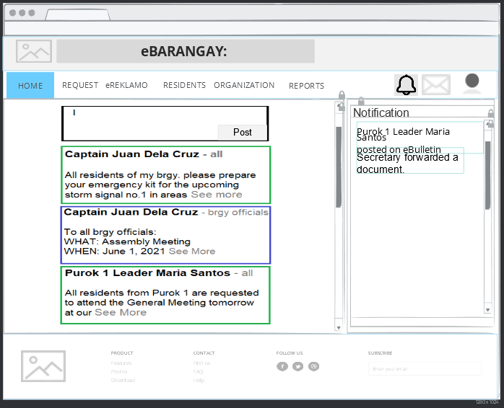

Figure 17: **Storyboard - Homepage**

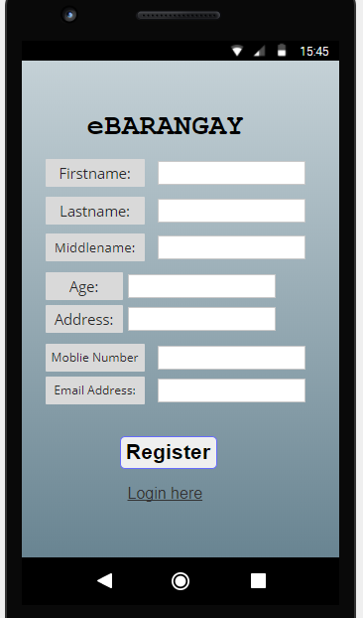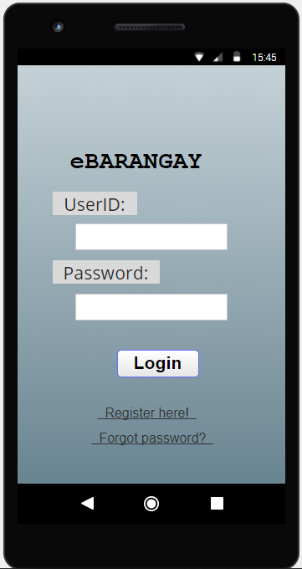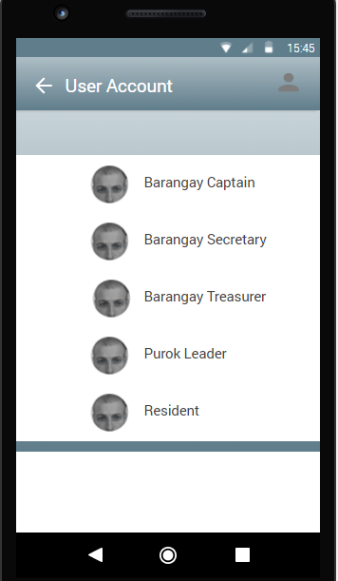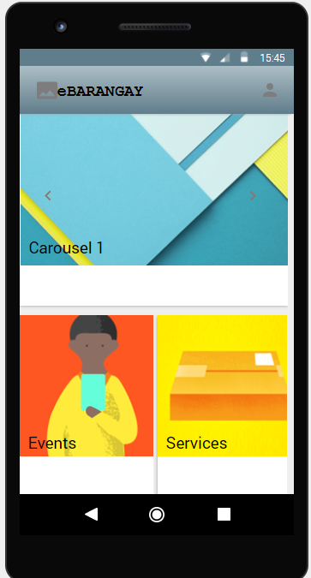Android

Figure 84: **Storyboard – Android - Homepage**

Figure 87: **Storyboard – Register**

Figure 86: **Storyboard – Login**

Figure 85: **Storyboard – User account**

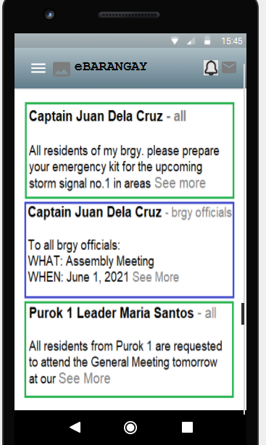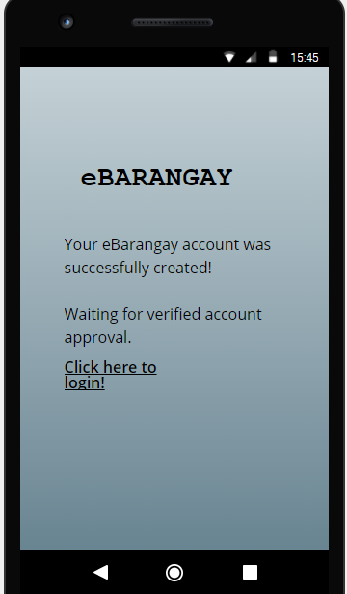

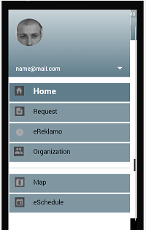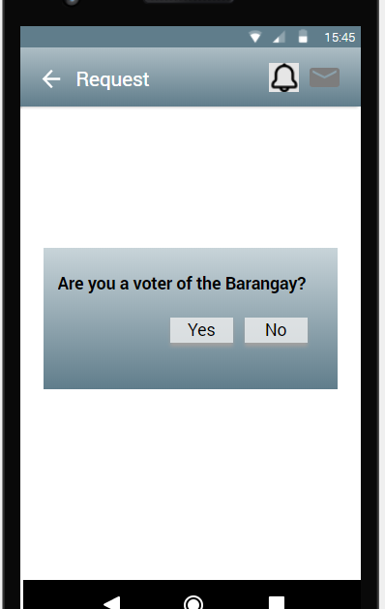

Figure 91: **Storyboard – Request**

Figure 90: **Storyboard – Menu**

Figure 89: **Storyboard – eBulletin**

Figure 88: **Storyboard – Account created**

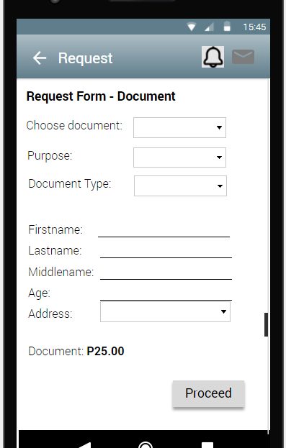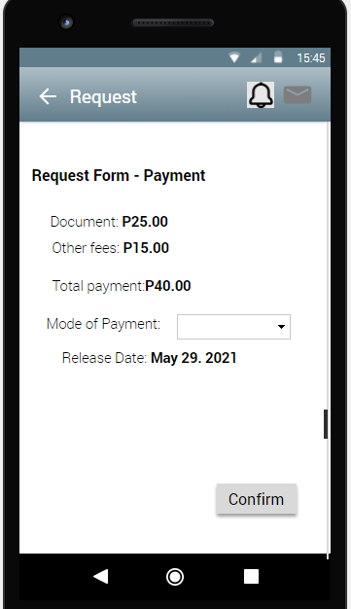

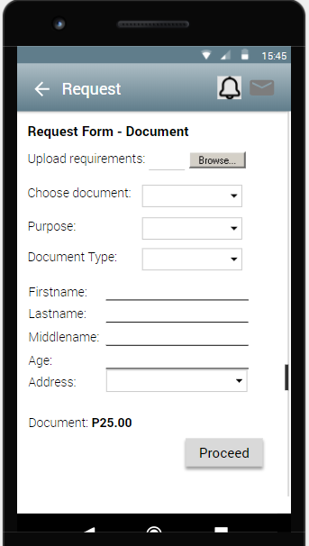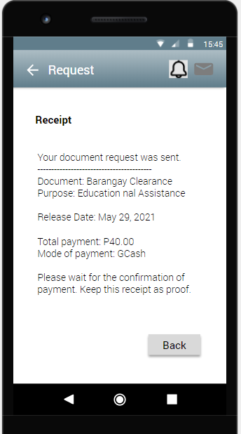

Figure 95: **Storyboard – Request Document (NON-VOTER)**

Figure 94: **Storyboard – Receipt**

Figure 92: **Storyboard – Request Docu**

Figure 93: **Storyboard – Payment**

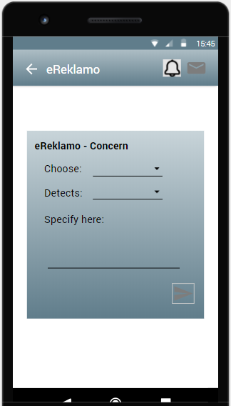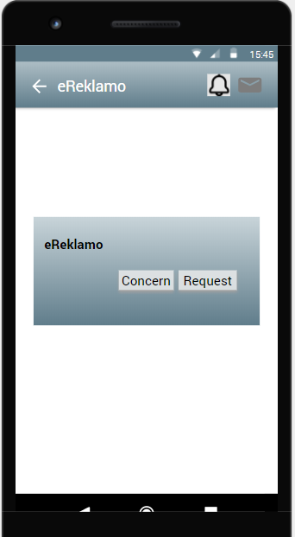

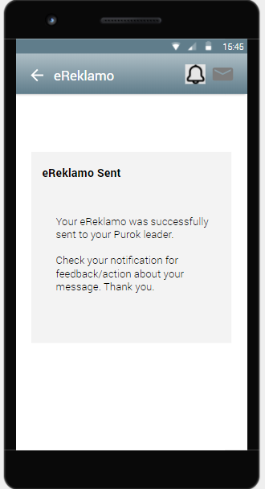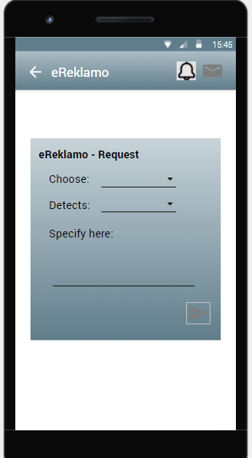

Figure 97: **Storyboard – eReklamo Concern**

Figure 96: **Storyboard – eReklamo**

Figure 99: **Storyboard – eReklamo sent**

Figure 98: **Storyboard – eReklamo Request**

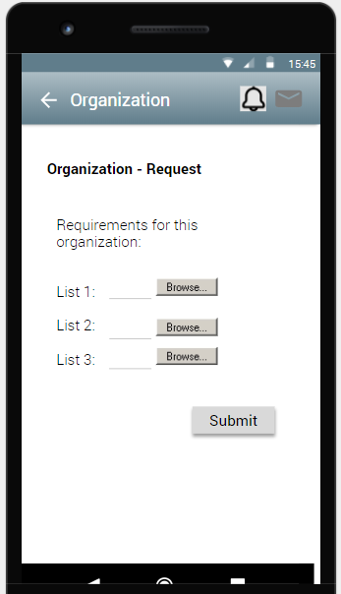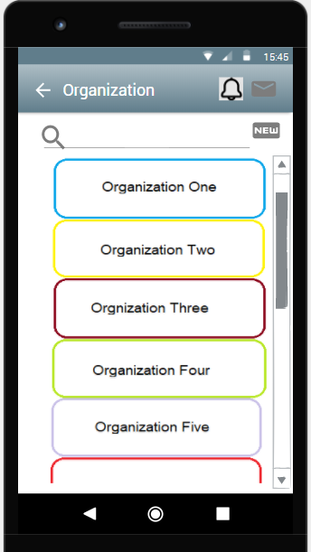

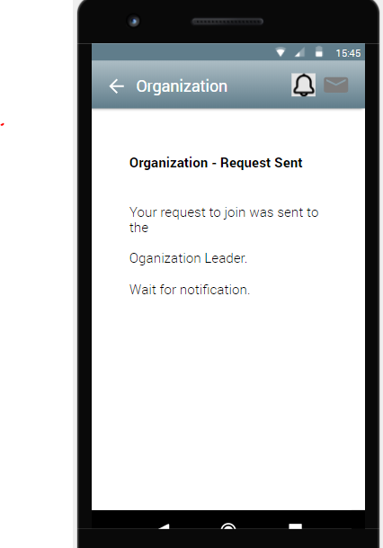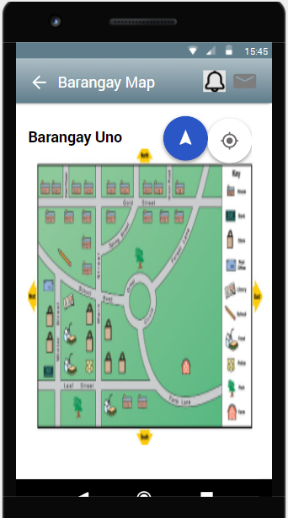

Figure 103: **Storyboard – Map**

Figure 102: **Storyboard – Request Join sent**

Figure 101: **Storyboard – Join Org**

Figure 100: **Storyboard – Organization**

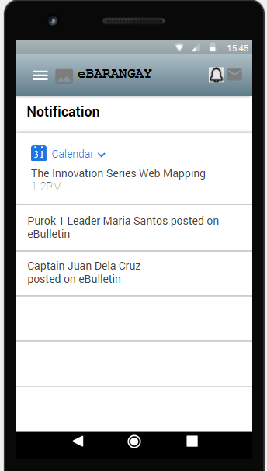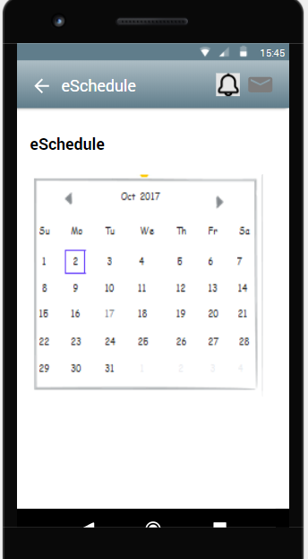

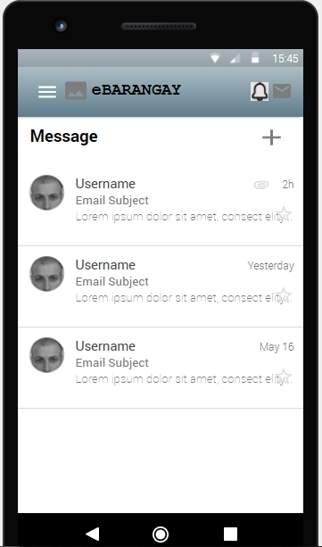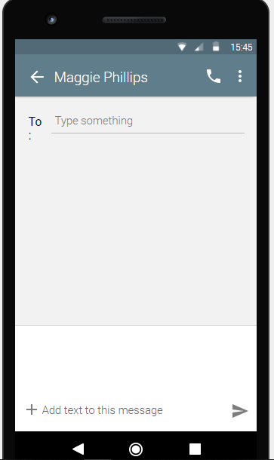

Figure 107: **Storyboard – Compose message**

Figure 106: **Storyboard – Messages**

Figure 105: **Storyboard – Notification**

Figure 104: **Storyboard – eSchedule**

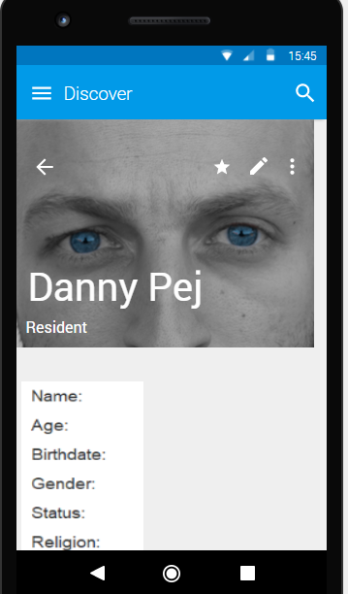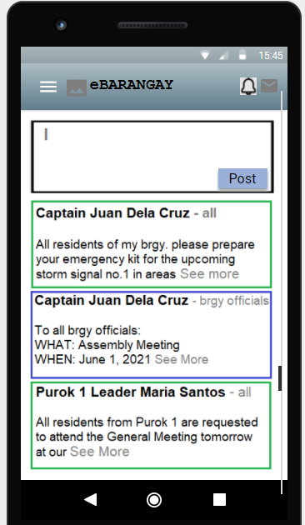

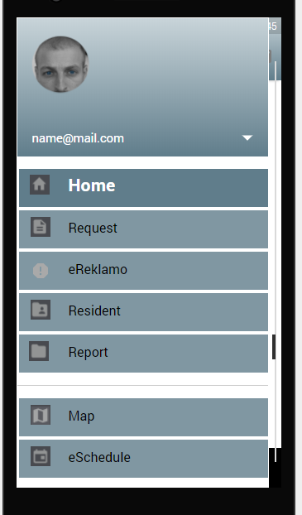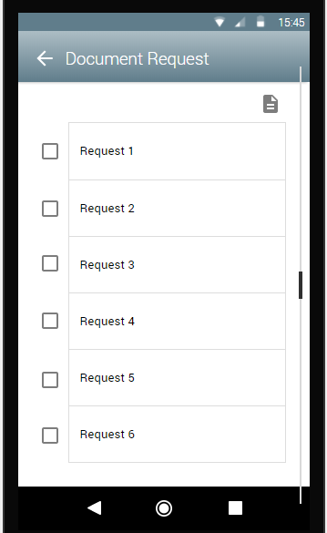

Figure 111: **Storyboard – Document Request**

Figure 110: **Storyboard – Menu**

Figure 109: **Storyboard – LEADER eBulletin**

Figure 108: **Storyboard – Resident Profile**

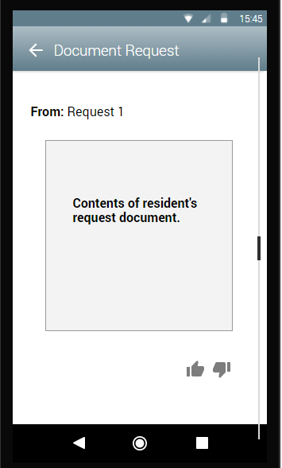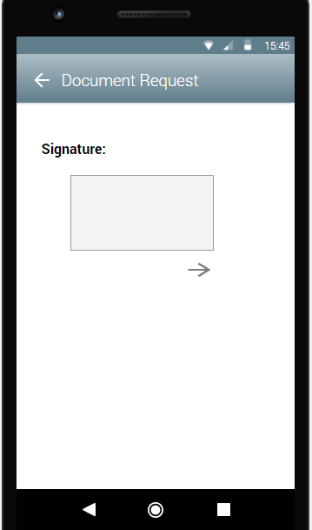

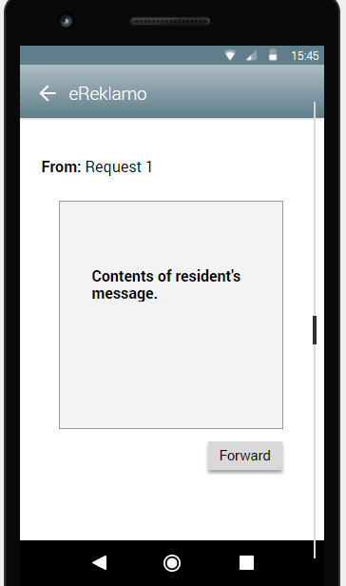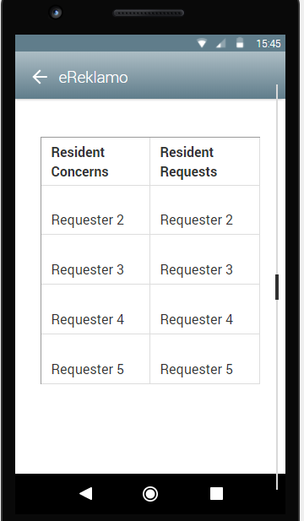

Figure 115: **Storyboard – Resident message**

Figure 114: **Storyboard – eReklamo**

Figure 112: **Storyboard – Document Request Content**

Figure 113: **Storyboard – Signature**

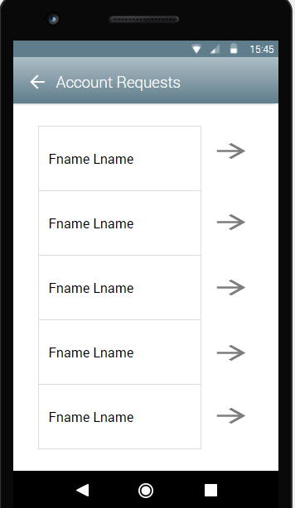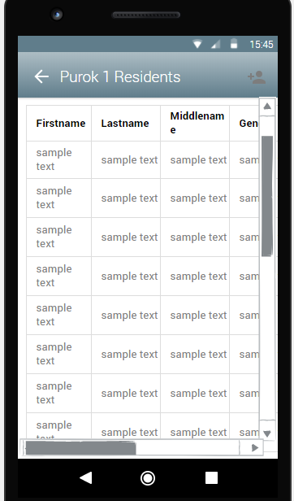

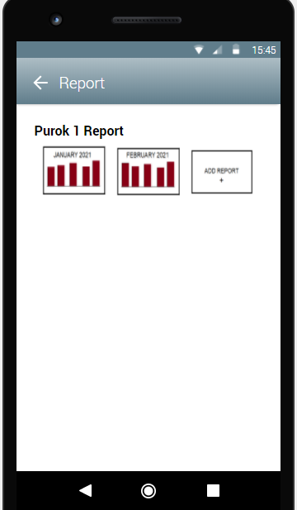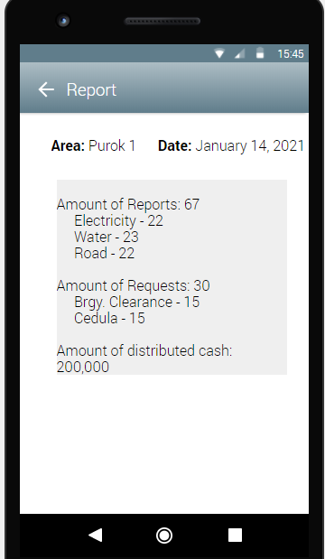

Figure 119: **Storyboard – Report content**

Figure 118: **Storyboard – Reports**

Figure 116: **Storyboard – Resident list**

Figure 117: **Storyboard – Account requests**

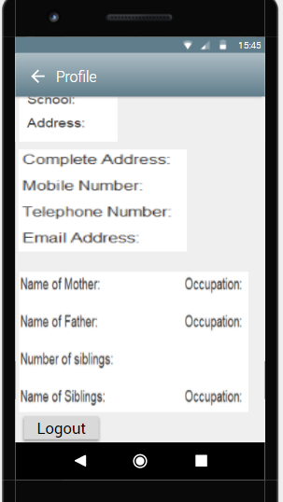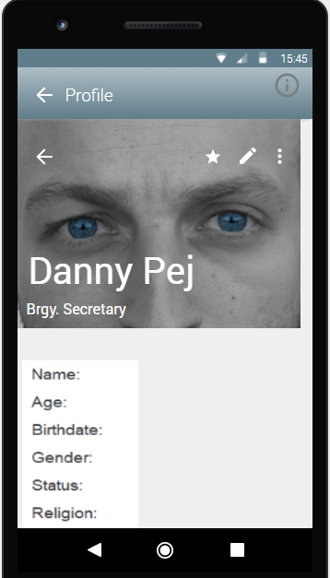

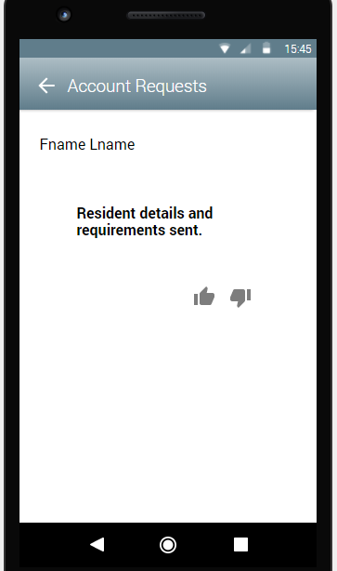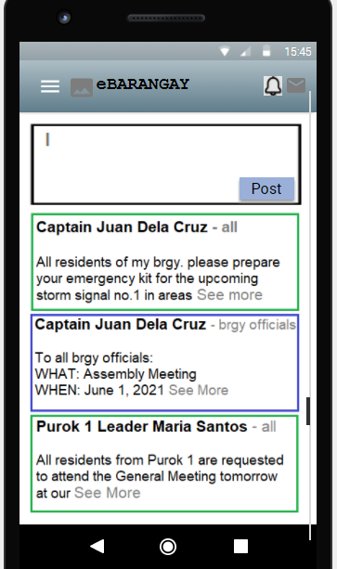

Figure 123: **Storyboard – eBulletin**

Figure 122: **Storyboard – Account request**

Figure 121: **Storyboard – Secretary Profile**

Figure 120: **Storyboard – Secretary Profile**

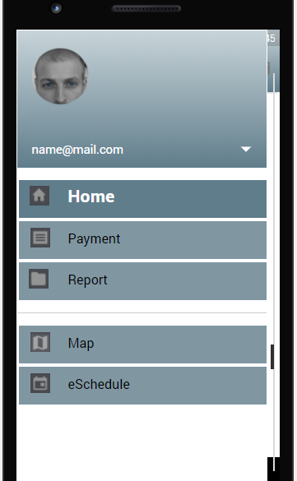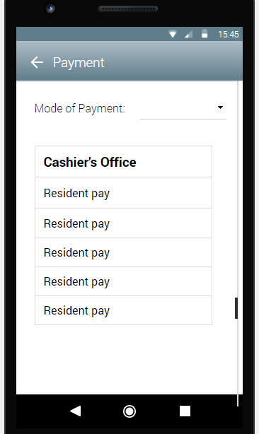

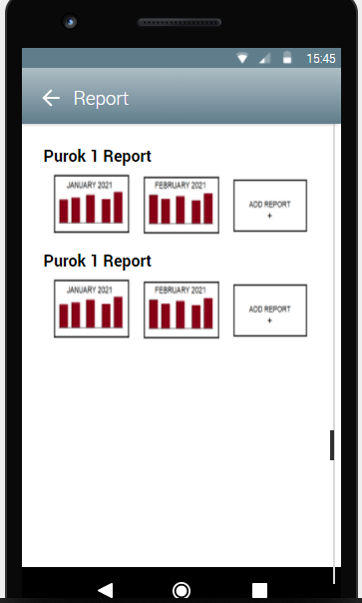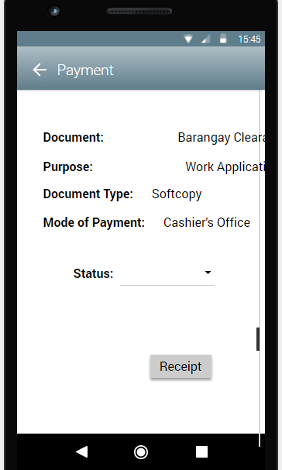

Figure 127: **Storyboard – Report**

Figure 126: **Storyboard – Payment Details**

Figure 125: **Storyboard – Payment**

Figure 124: **Storyboard – menu**

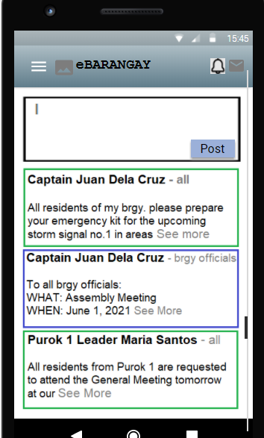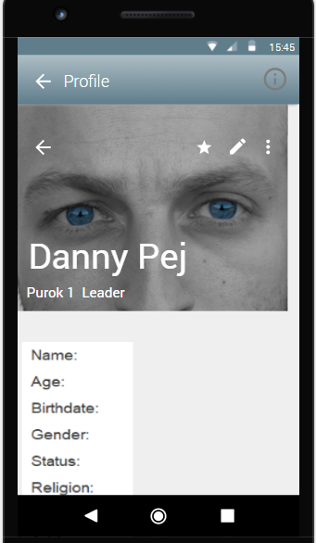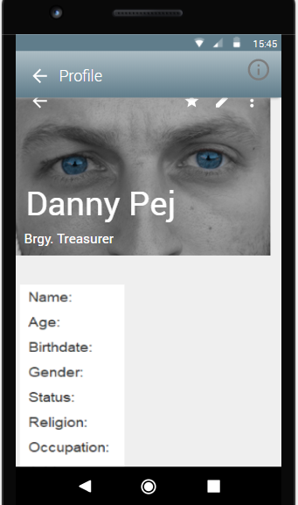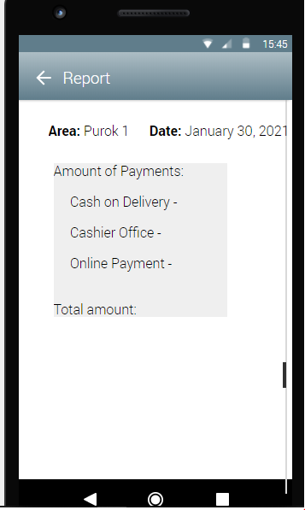

Figure 131: **Storyboard – eBulletin**

Figure 130: **Storyboard – Purok Leader profile**

Figure 128: **Storyboard – Report Detail**

Figure 129: **Storyboard – Brgy. Treasurer profile**

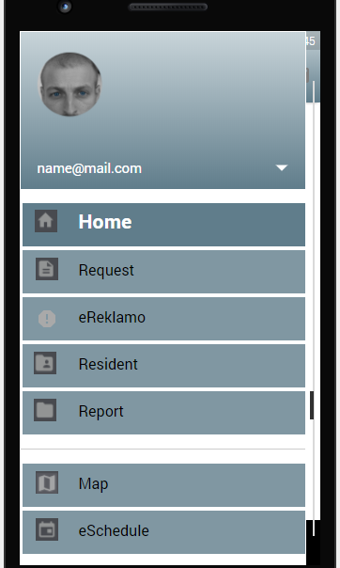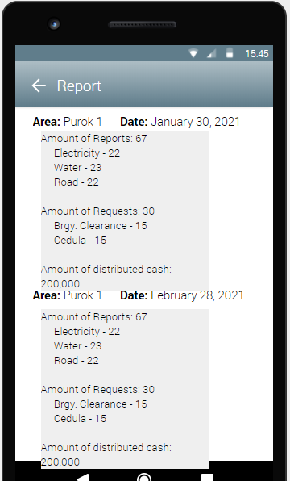

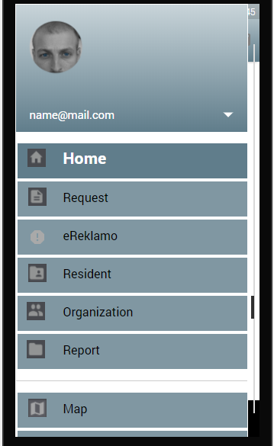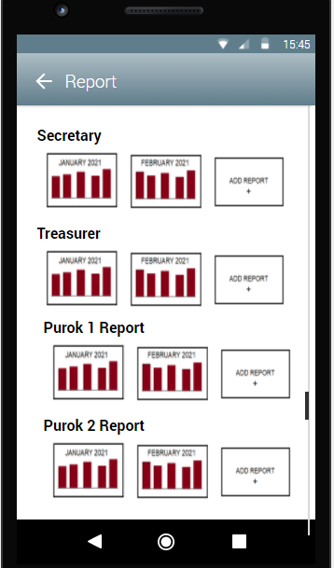

Figure 135: **Storyboard – Report**

Figure 134: **Storyboard – Menu**

Figure 133: **Storyboard – Report details**

Figure 132: **Storyboard – Menu**

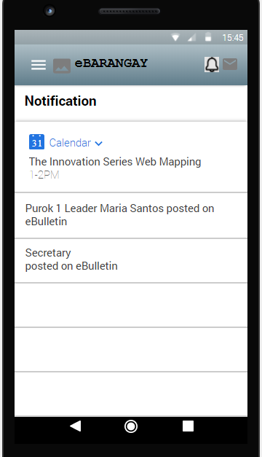

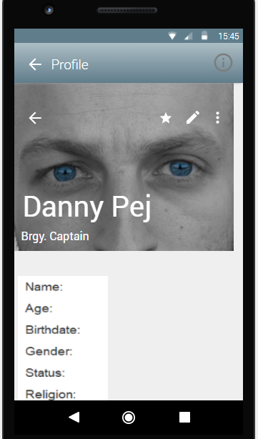

Figure 136: **Storyboard – Notification**

Figure 137: **Storyboard – Brgy. Captain profile**

**Database Design**

**Entity-Relationship Diagram**

An entity relationship diagram (ERD) shows the relationships of entity sets stored in a database. An entity in this context is an object, a component of data. An entity set is a collection of similar entities. These entities can have attributes that define its properties.

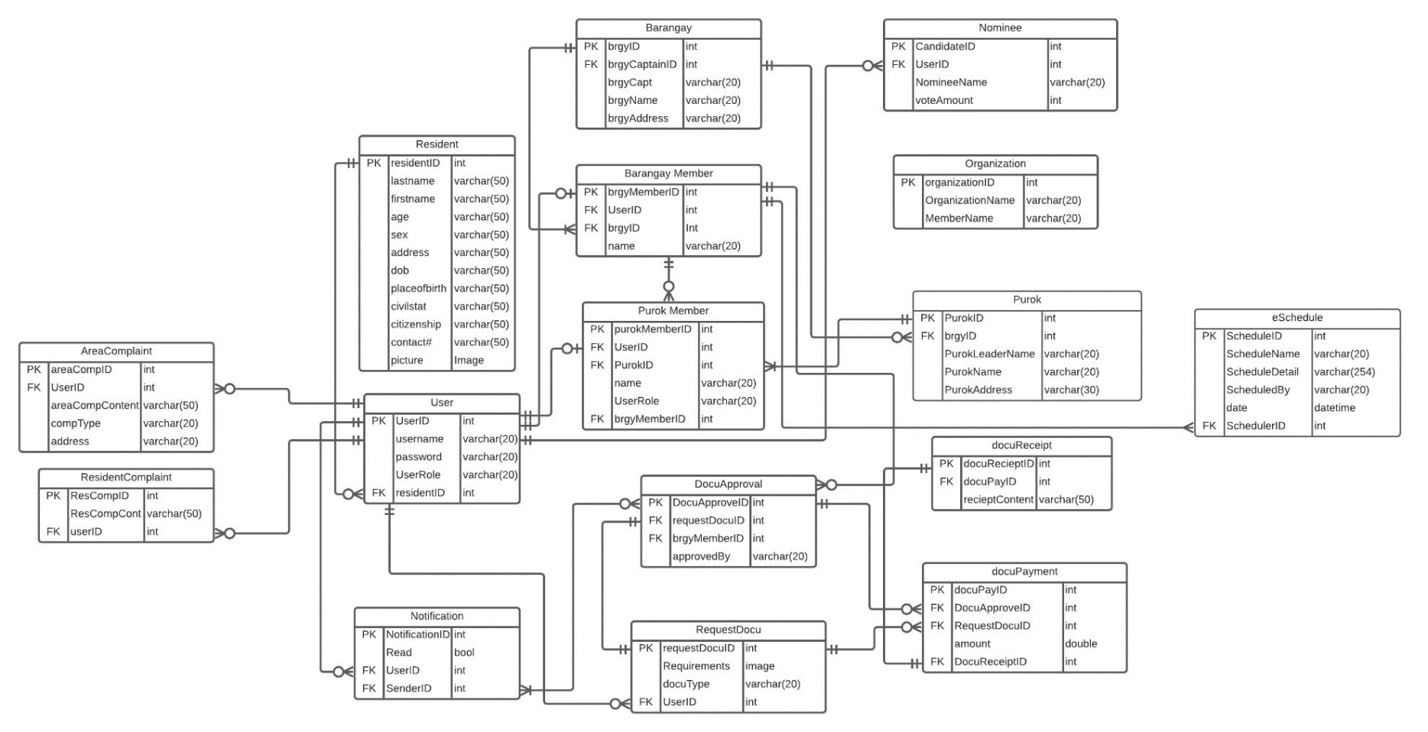

Figure 138: **Entity-Relationship Diagram**

**Data Dictionary**

A data dictionary is a collection of the names, definitions, and attributes for data elements and models. The data in a data dictionary is the metadata about the database. These elements are then used as part of a database, research project, or information system.

|  |  |  |  |  |  |  |  |  |
| --- | --- | --- | --- | --- | --- | --- | --- | --- |
| Table Name | Attribute Name | Contents | Type | Format | Range | Req  uired | PK OR FK | FK REFERENCED TABLE |
| Resident | ResidentID  Lastname  Firstname  Age  Sex  Address  Date of Birth  Place of Birth  Civil Status  Citizenship  Contact#  Picture | Resident ID  Resident’s Lastname  Resident’s Firstname  Resident’s Age  Resident’s Sex  Resident’s Age  Resident’s DOB  Resident’s Place of Birth  Resident’s Civil Status  Resident’s Citizenship  Resident’s Contact#  Resident’s 2x2 Pic | INT  VARCHAR(50)  VARCHAR(50)  VARCHAR(50)  VARCHAR(50)  VARCHAR(50)  VARCHAR(50)  VARCHAR(50)  VARCHAR(50)  VARCHAR(50)  VARCHAR(50)  IMAGE | 999999  Xxxx xxxxx  Xxxx xxxxx  Xxxx xxxxx  Xxxx xxxxx  Xxxx xxxxx  Xxxx xxxxx  Xxxx xxxxx  Xxxx xxxxx  Xxxx xxxxx  Xxxx xxxxx | 000001-999999 | Y  Y  Y  Y  Y  Y  Y  Y  Y  Y  Y | PK |  |
| User | UserID  Username  Password  UserRole  residentID | User’s ID  Username for login  Password for login  Roles of the User  Resident ID linked | INT  VARCHAR(20)  VARCHAR(20)  VARCHAR(20)  INT | 999999  Xxxx xxxxx  Xxxx xxxxx  Xxxx xxxxx  999999 | 000001-999999  000001-999999 | Y  Y  Y  Y | PK  FK | Resident |
| Notification | NotificationID  Read  UserID  SenderID | Notification’s ID  Read status  User’s ID  Sender’s ID | INT  BOOL  INT  INT | 999999  X  999999  999999 | 000001-999999  000001-999999  000001-999999 | Y  Y  Y  Y | PK  FK  FK | User  DocuApproval |
| Barangay | BrgyID  BrgyCaptainID  BrgyCaptName  BrgyName  BrgyAddress | Barangay ID  Brgy captain’s brgymemberID  Barangay Captain’s Name  Barangay Name  Barangay Address | INT  INT  VARCHAR(20)  VARCHAR(20)  VARCHAR(20) | 999999  999999  Xxxx xxxxx  Xxxx xxxxx  Xxxx xxxxx | 000001-999999  000001-999999 | Y  Y  Y  Y  Y | Y | Barangay Member |
| Barangay Member | BrgyMemberID  UserID  BrgyID  Name | Barangay member’s ID  User’s ID  Barangay ID  Barangay Member’s name | INT  INT  INT  VARCHAR(20) | 999999  999999  999999  Xxxx xxxxx | 000001-999999  000001-999999  000001-999999 | Y  Y  Y  Y | PK  FK  FK | User  Barangay |

|  |  |  |  |  |  |  |  |  |  |  |  |
| --- | --- | --- | --- | --- | --- | --- | --- | --- | --- | --- | --- |
| Purok | PurokID  BrgyID  PurokName  PurokAddress | Purok ID  Barangay’s ID  Purok’s Name  Purok’s Address | INT  INT  VARCHAR(20)  VARCHAR(20) | 999999  999999  Xxxx xxxxx  Xxxx xxxxx | 000001-999999  000001-999999 | Y  Y  Y  Y | | PK  FK | Barangay | | |
| Purok Member | purokMemberID  UserID  PurokID  Name  UserRole | Purok Member’s ID  User ID  Purok’s ID  Purok Member’s Name  Purok Member’s Role | INT  INT  INT  VARCHAR(20)  VARCHAR(20) | 999999  999999  999999  Xxxx xxxxx  Xxxx xxxxx | 000001-999999  000001-999999  000001-999999 | Y  Y  Y | | PK  FK  FK | User  Purok Member | | |
| Nominee | NomineeID  UserID  VoteAmount | Nominee’s ID  User’s ID  Amount of votes they got | INT  INT  INT | 999999  999999  999999 | 000001-999999  000001-999999  000001-999999 | Y  Y  Y | | PK  FK | User | | |
| Organization | OrganizationID  OrganizationName  MemberName | Organization’s ID  Organization’s Name  Member’s Name | INT  VARCHAR(20)  VARCHAR(20) | 999999  Xxxx xxxxx  Xxxx xxxxx | 000001-999999 | Y  Y  Y | | PK |  | | |
| Notification | NotificationID  Read  UserID  SenderID | Notification’s ID  Check user read status  User’s ID  Sender’s ID | INT  BOOL  INT  INT | 999999  X  999999  999999 | 000001-999999  0-1  000001-999999  000001-999999 | Y  Y  Y | | PK  FK  FK | User  DocuApproval | | |
| DocuApproval | DocuApprovalID  RequestDocuID  BrgyMemberID  ApprovedBy | Approved document’s ID  Requested document’s ID  Barangay Member’s ID  Approved by name of brgy member | INT  INT  INT  VARCHAR(20) | 999999  999999  999999  Xxxx xxxxx | 000001-999999  000001-999999  000001-999999 | Y  Y  Y  Y | | PK  FK  FK | RequestDocu  Purok Member | | |
| RequestDocu | RequestDocuID  Requirements  DocuType  UserID | Requested Document’s ID  Requirements needed  Document type  User’s ID | INT  IMAGE  VARCHAR(20)  INT | 999999  Xxxx xxxxx  999999 | 000001-999999  000001-999999 | Y  Y  Y | | PK  FK | User | | |
| DocuPayment | DocuPayID  DocuApproveID  RequestDocuID  Amount  DocuReceiptID | Docupay’s ID  Approved document’s ID  Requested Document’s ID  Amount to be paid  Receipt for transaction | INT  INT  INT  NUMBER(9,2)  INT | 999999  999999  999999  999999999.99  999999 | 000001-999999  000001-999999  000001-999999  000000001.00-999999999.99  000001-999999 | Y  Y  Y  Y  Y | | PK  FK  FK  FK | DocuApproval  RequestDocu  DocuReceipt | | |
| DocuReceipt | DocuReceiptID  DocuPayID  ReceiptContent | DocuReceipt’s ID  DocuPay’s ID  Receipt’s Content | INT  INT  VARCHAR(20) | 999999  999999  Xxxx xxxxx | 000001-999999  000001-999999 | Y  Y | | PK  FK | DocuPayment | | |
| eBulletin | eBulletinID  PostContent  PostImage  PosterID  PostedOn | eBulletin’s ID  Content of the Post  Image of the Post  brgyMemberID of the poster  Date posted on | INT  VARCHAR(254)  IMAGE  INT  DATETIME | 999999  Xxxxx xxxxx  999999  MMMM/dd/YY HH:MM | 000001-999999  000001-999999 | | Y  Y  Y  Y | PK  FK | | Barangay Member |
| eSchedule | ScheduleID  ScheduleName  ScheduleDetail  ScheduledBy  Date  SchedulerID | Schedule’s ID  Name of the event  Details of the event  Name of the scheduler  Date of the event  Barangay Member’s ID | INT  VARCHAR(20)  VARCHAR(254)  VARCHAR(20)  DATETIME  INT | 999999  Xxxxx xxxxx  Xxxxx xxxxx  Xxxxx xxxxx  MMMM/dd/YY HH:MM  999999 | 000001-999999  000001-999999 | | Y  Y  Y  Y  Y  Y | PK  FK | | Barangay Member |

Table 5: **eBarangay Data Dictionary**

**Network Design**

Network design in a representation of the implementation of the systems network infrastructure. This design includes Network Topology and Network Model.

**Network Model**

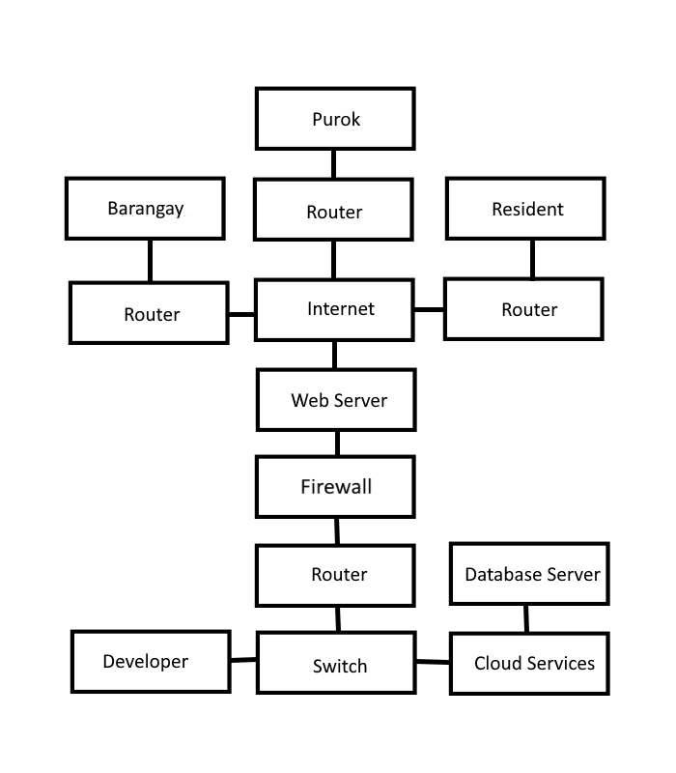The network model is a database model conceived as a flexible way of representing objects and their relationships. Its distinguishing feature is that the schema, viewed as a graph in which object types are nodes and relationship types are arcs, is not restricted to being a hierarchy or lattice.

Figure 139: **Network Model**

eBarangay uses the TCP/IP as a framework for its network model. It serves as a peer-to-peer network connectivity for the developer, barangay, purok, and residents. It also uses Local Area Network (LAN) among computers and other devices that are connected within the same router.

**Network Topology**

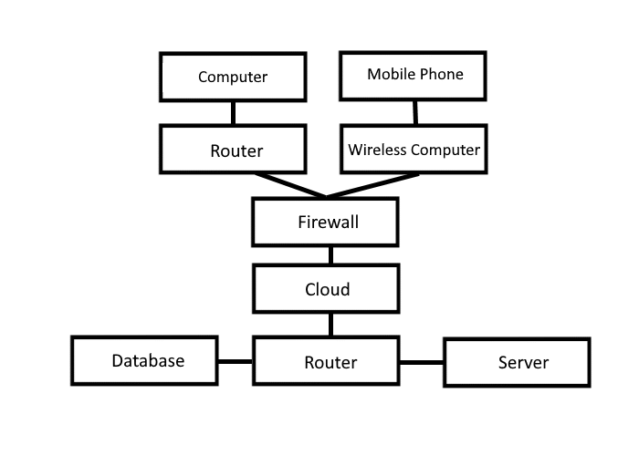 Network topology refers to the manner in which the links and nodes of a network are arranged to relate to each other. Topologies are categorized as either physical network topology, which is the physical signal transmission medium, or logical network topology, which refers to the manner in which data travels through the network between devices, independent of physical connection of the devices.

Figure 140: **Network Topology**

eBarangay uses a Star topology as its Network Topology. Users, such as the residents, purok leaders, and barangay officials can use can access the system online through desktop computers, and through their mobile devices such as laptops and mobile phones utilizing the accessibility of the internet.

**Development Phase**

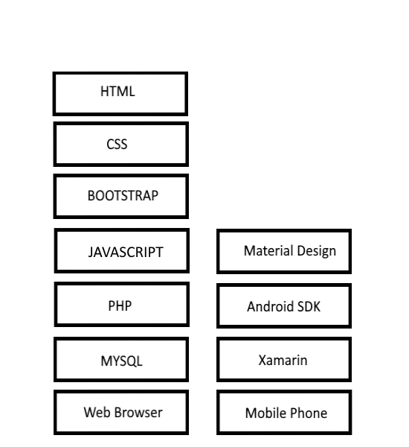**Technology Stack Diagram**

Figure 141: **Techonology Stack Diagram**

eBarangay will be developed with a sufficient amount of software. The software will be used in web developing for front end are Boostrap 4, CSS 3, Javascript, and HTML 5 while for backend the system will be using PHP and MYSQL. On mobile devices, eBarangay will utilize Material Design, Android SDK and Xamarin for its frontend and backend.

**Software Specification**

SYSTEM SPECIFICATION DEVELOPMENT STAGE

Software Specification Development

Browser: Google Chrome, Mozilla Firefox, and/or Microsoft Edge

Operating System: Windows 7 or up

Internet Speed: 3 Mbps or higher

Application Tools: Visual Studio 2019

**Hardware Specification**

Hardware Specification refers to the requirement of the device hardware in order to perform functions.

Development Stage

|  |  |
| --- | --- |
| **Processor** | Intel® Core™ i5-4460 CPU @3.20GHz 3.20GHz |
| **Memory/RAM** | 8192mb or Higher |
| **Hard Disk Drive** | 500gb or Higher |
| **Monitor** | 15 inches 1366x768 60Hz |
| **Video Adapter** | Intel ® HD Graphics 3000 |
| **Keyboard** | Generic Keyboard |
| **Mouse** | Generic Mouse |
| **Ethernet Adapterx** | Realtek PCIe FE Family Controller |
| **Disk Drive** | DVD-R/W Driver |
| **USB Port** | 2.0 USB port or 3.0 USB port |

**Program Specification**

**List of Modules**

|  |  |  |  |  |  |
| --- | --- | --- | --- | --- | --- |
| Programmer | MODULES | RESIDENTS | PUROK | BARANGAY | ADMIN |
|  | MANAGE ACCOUNT | | | |  |
| CREATE ACCOUNT | * |  |  |  |
| VIEW ACCOUNT | * | * | * | * |
| UPDATE ACCOUNT | * | * | * | * |
| DELETE ACCOUNT |  |  |  | * |
| VERIFY PROFILE | * | * | * |  |
| LOGIN & OUT | * | * | * | * |
| Number of Points  (1 Point per module per user) | | 1 | 1 | 1 | 1 |

Table 6: **Manage Account Module**

|  |  |  |  |  |  |
| --- | --- | --- | --- | --- | --- |
| Programmer | MODULES | RESIDENTS | PUROK | BARANGAY | ADMIN |
|  | REQUEST DOCUMENT | | | | |
| CREATE REQUEST | * |  |  |  |
| VIEW REQUEST | * | * | * | * |
| UPDATE REQUEST | * | * | * |  |
| CANCEL REQUEST | * |  |  |  |
| APPROVE/DISAPPROVE REQUEST |  | * | * |  |
| Number of Points  (1 Point per module per user) | | 1 | 1 | 1 | 1 |

Table 7: **Request Document Module**

Table 15: **Request Document Module**

|  |  |  |  |  |  |
| --- | --- | --- | --- | --- | --- |
| Programmer | MODULES | RESIDENTS | PUROK | BARANGAY | ADMIN |
|  | EBULLETIN | | | | |
| VIEW POST | * | * | * | * |
| CREATE POST | * | * | * |  |
| UPDATE POST | * | * | * |  |
| DELETE POST | * | * | * | * |
| Number of Points  (1 Point per module per user) | | 1 | 1 | 1 | 1 |

Table 8: **eBulletin Module**

|  |  |  |  |  |  |  |  |
| --- | --- | --- | --- | --- | --- | --- | --- |
| Programmer | MODULES | |  | RESIDENTS | PUROK | BARANGAY | ADMIN |
|  |  | MANAGE COMPLAINTS | | | | | |
| VIEW COMPLAINT | |  | * | * | * | * |
| EDIT COMPLAINT | |  | * |  |  |  |
| SEND COMPLAINT | |  | * |  |  |  |
| RECORD COMPLAINTS | |  |  | * | * |  |
| Number of Points  (1 Point per module per user) | | |  | 1 | 1 | 1 | 1 |

Table 9: **Manage Complaints Module**

Table 15: **Manage Complaints Module**

|  |  |  |  |  |  |
| --- | --- | --- | --- | --- | --- |
| Programmer | MODULES | RESIDENTS | PUROK | BARANGAY | ADMIN |
|  | MANAGE RESIDENTS | | | | |
| VIEW RESIDENTS | * | * | * | * |
| UPDATE RESIDENTS |  | * | * |  |
| ADD RESIDENTS |  | * | * |  |
| DELETE RESIDENTS |  |  | * | * |
| VERIFY RESIDENTS |  | * | * |  |
| Number of Points  (1 Point per module per user) | | 1 | 1 | 1 | 1 |

Table 10: **Manage Residents Module**

|  |  |  |  |  |  |
| --- | --- | --- | --- | --- | --- |
| Programmer | MODULES | RESIDENTS | PUROK | BARANGAY | ADMIN |
|  | MANAGE ORGANIZATIONS | | | | |
| CREATE ORGANIZATION | * |  | * | * |
| VIEW ORGANIZATIONS | * | * | * | * |
| UPDATE ORGANIZATION |  |  | * | * |
| DELETE ORGANIZATION |  |  | * | * |
| CANCEL REQUEST | * |  |  |  |
| APPROVE/DISAPPROVE REQUEST |  | * | * |  |
| Number of Points  (1 Point per module per user) | | 1 | 1 | 1 | 1 |

Table 11: **Manage Organizations Module**

|  |  |  |  |  |  |
| --- | --- | --- | --- | --- | --- |
| Programmer | MODULES | RESIDENTS | PUROK | BARANGAY | ADMIN |
|  | MANAGE NOTIFICATION/MESSAGES | | | | |
| PUSH | * | * | * |  |
| SEND MESSAGE | * | * | * |  |
| Number of Points  (1 Point per module per user) | | 1 | 1 | 1 | 0 |

Table 12: **Manage Notification/Messages Module**

|  |  |  |  |  |  |
| --- | --- | --- | --- | --- | --- |
| Programmer | MODULES | RESIDENTS | PUROK | BARANGAY | ADMIN |
|  | MANAGE BARANGAY | | | | |
| VIEW BARANGAY | * | * | * | * |
| CREATE BARANGAY |  |  |  | * |
| UPDATE  BARANGAY |  |  | * | * |
| DELETE BARANGAY |  |  |  | * |
| Number of Points  (1 Point per module per user) | | 1 | 1 | 1 | 1 |

Table 13: **Manage Barangay Module**

|  |  |  |  |  |  |
| --- | --- | --- | --- | --- | --- |
| Programmer | MODULES | RESIDENTS | PUROK | BARANGAY | ADMIN |
|  | VOTING | | | | |
| ADD CANDIDATE |  |  | * | * |
| UPDATE CANDIDATE |  |  | * | * |
| REMOVE  CANDIDATE |  |  | * | * |
| VIEW  CANDIDATE | * | * | * | * |
| VOTE CANDIDATE | * | * | * |  |
| Number of Points  (1 Point per module per user) | | 1 | 1 | 1 | 1 |
| Number of Modules Per User | | 9 | 9 | 9 | 8 |

Table 14: **Voting Module**

**REFERENCES**

Ramirez, N. (2017, May 16). San Fran’s purok system, a deterrent against criminals.

CebuDailyNews. Retrieved from https://bit.ly/3x5vlpa

# Matthies, A. (2017). “Community-Based Disaster Risk Management in the Philippines: Achievements and challenges of the Purok System.” Austrian Journal of South-East Asian Studies, 10(1), 101-108. Retrieved from https://bit.ly/3qmtMkg

# Cheng, R. R. (2019). Building Community-based Resilience in the Municipality of San Francisco, Cebu, Philippines. GDI. Retrieved from https://bit.ly/3vSHYmr

# Curato, N., Calamba, S. T. (2018). Surviving Disasters by Suppressing Political Storms: Participition as Knowledge Transfer in Community-Based Disaster Governance. Sage Journals. Retrieved from <https://bit.ly/2T0SDOn>

# Ponce de Leon, I. Z. (2021). International Journal of Disaster Risk Reduction. ScienceDirect. Retrieved from <https://bit.ly/2TYSFGC>

# Institutionalizing the purok system. (2017, October). CebuDailyNews. Retrieved from https://bit.ly/3gYoRSt

**APPENDICES**

**Appendix A. Capstone 1 Oath of Confirmation**





**Appendix B. Research Working Title Form**

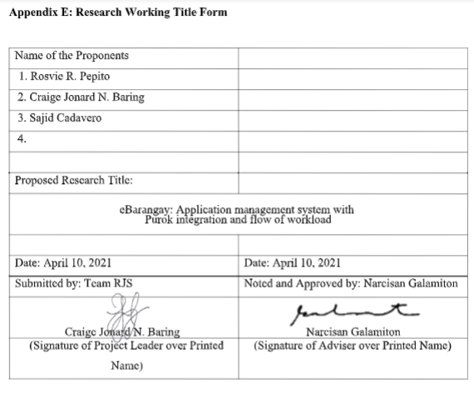

**Appendix C. Capstone 1 Consultation Logs Form**

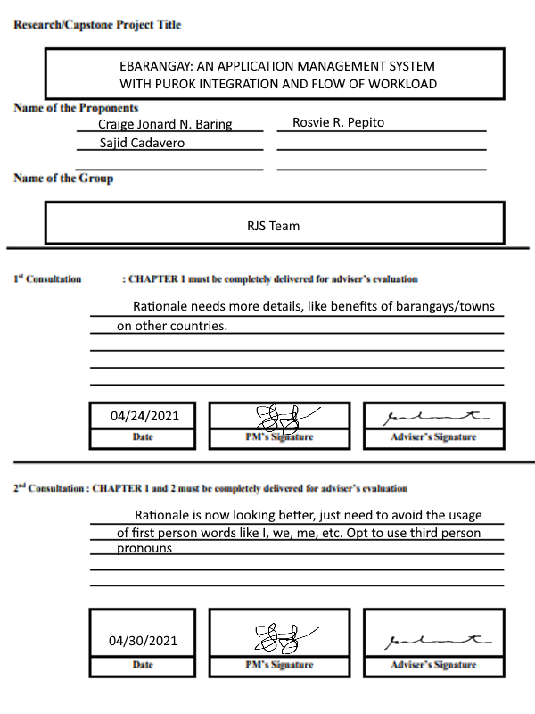

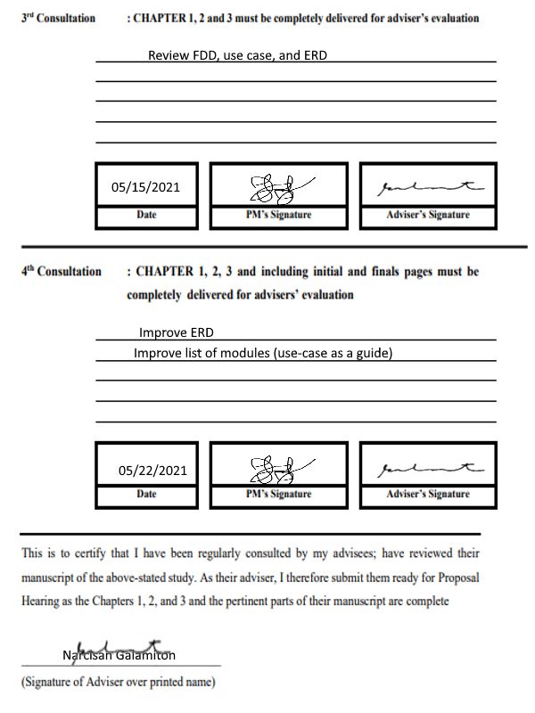

**CURRICULUM VITAE**



Name : CRAIGE JONARD N. BARING

Address : KAMANGGAHAN 1, PAJO, LAPU- LAPU CITY, CEBU

E-Mail Address : craigejonard@gamil.com

**PERSONAL DATA:**

Gender : MALE

Age : 21

Religion : ROMAN CATHOLIC

Civil Status : SINGLE

Citizenship : FILIPINO

Date of Birth : JANUARY 7, 2000

Place of Birth : LAPU-LAPU CITY

**EDUCATIONAL BACKGROUND**

SENIOR HIGH SCHOOL

School : UNIVERSITY OF CEBU - LAPU-LAPU AND MANDAUE

Address : A.C. CORTES AVE, MANDAUE CITY, 6014 CEBU

Year Graduated : 2017-2018

JUNIOR HIGH SCHOOL

School : UNIVERSITY OF CEBU - LAPU-LAPU AND MANDAUE

Address : A.C. CORTES AVE, MANDAUE CITY, 6014 CEBU

Year Graduated : 2015-2016

ELEMENTARY

School : UNIVERSITY OF CEBU - LAPU-LAPU AND MANDAUE

Address : A.C. CORTES AVE, MANDAUE CITY, 6014 CEBU

Year Graduated : 2011-2012

Name : SAJID O. CADAVERO

Address : M6 SITIO KAMANGGAHAN, LABOGON, MANDAUE CITY, CEBU

E-Mail Address : sajidcadavero@gmail.com

**PERSONAL DATA:**

Gender : MALE

Age : 21

Religion : ROMAN CATHOLIC

Civil Status : SINGLE

Citizenship : FILIPINO

Date of Birth : JUNE 28, 1999

Place of Birth : CEBU CITY

**EDUCATIONAL BACKGROUND**

SENIOR HIGH SCHOOL

School : ST. JOSEPH’S ACADEMY

Address : MANDAUE CITY, CEBU

Year Graduated : 2017-2018

JUNIOR HIGH SCHOOL

School : ST. JOSEPH’S ACADEMY

Address : MANDAUE CITY, CEBU

Year Graduated : 2015-2016

ELEMENTARY

School : ST. JOSEPH’S ACADEMY

Address : MANDAUE CITY, CEBU

Year Graduated : 2011-2012

Name : ROSVIE R. PEPITO

Address : ZONE SIBUYAS, PAKNAAN, MANDAUE CITY, CEBU

E-Mail Address : pepitorosvie@gmail.com

**PERSONAL DATA:**

Gender : FEMALE

Age : 21

Religion : ROMAN CATHOLIC

Civil Status : SINGLE

Citizenship : FILIPINO

Date of Birth : AUGUST 23, 1999

Place of Birth : BORBON, CEBU

**EDUCATIONAL BACKGROUND**

SENIOR HIGH SCHOOL

School : UNIVERSITY OF CEBU - LAPU-LAPU AND MANDAUE CAMPUS

Address : A.C. CORTES AVE, MANDAUE CITY, 6014 CEBU

Year Graduated : 2017-2018

JUNIOR HIGH SCHOOL

School : DON EMILIO OSMENA MEMORIAL HIGH SCHOOL

Address : SAGAY, BORBON, CEBU

Year Graduated : 2015-2016

ELEMENTARY

School : LAAW ELEMENTARY SCHOOL

Address : LAAW, BORBON, CEBU

Year Graduated : 2011-2012